Texas Coastal Nutrient Input Repository - Task 4 Report Statistical Models for Nutrient Loading into Lavaca Bay

Michael Schramm 1

1 Research Specialist, Texas Water Resources Institute, Texas A&M AgriLife Research

December 1, 2021

Texas Water Resources Institute

Texas A&M AgriLife

College Station, TX



This project was funded by a Texas Coastal Management Program grant approved by the Texas Land Commissioner, providing financial assistance under the Coastal Zone Management Act of 1972, as amended, awarded by the National Oceanic and Atmospheric Administration (NOAA), Oﬀice for Coastal Management, pursuant to NOAA Award No. NA21NOS4190136. The views expressed herein are those of the author(s) and do not necessarily reflect the views of NOAA, the U.S. Department of Commerce, or any of their subagencies.

Table of Contents

Table of Figures

Table of Tables

Abbreviations

| Acronym | Meaning |
| --- | --- |
| GAM | Generalized Additive Model |
| NO3-N | Nitrate-Nitrogen |
| NSE | Nash-Sutcliffe Efficency |
| PBIAS | Percent Bias |
| QAPP | Quality Assurance Project Plan |
| SD | Standard Deviation |
| SWAT | Soil & Water Assessment Tool |
| TCEQ | Texas Commission on Environmental Quality |
| TKN | Total Kjeldahl Nitrogen |
| TN | Total Nitrogen |
| TP | Total Phosphorus |
| TWDB | Texas Water Development Board |
| TxRR | Texas Rainfall-Runoff Model |
| USGS | United States Geological Survey |
| WRTDS | Weighted Regression on Time Discharge and Season |

# Summary

We quantified daily, monthly, and annual nutrient loading from freshwater segments in the Lavaca Bay watershed using a statistical modeling approach relating time and discharge to nutrient concentrations. Total combined annual nitrate loads ranged from 12,574 kg in 2011 to 794,510 kg in 2007 with a mean annual load of 205,405 kg per year from 2005 through 2020. Total combined annual total phosphorus loads ranges from 7,839 kg in 2011 to 916,908 kg in 2004 with a mean annual load of 241,681 kg per year from 2000 through 2020. Model validation indicated the approach performed well for predicting nutrient loads at the two most downstream sites in the watershed (Lavaca River near Edna, USGS-08164000 and Lake Texana at Palmetto Bend Dam, USGS-0816425). Additional flow-biased monitoring would improve model performance and validation during important high flow events that are the primary drivers of loading to Lavaca Bay. Model performance suffered at upstream sites to due higher variance in the measured data and insufficient sampling.

# Introduction

Excessive nutrient loading is driving eutrophication in a continually increasing proportion of coastal estuaries (Bricker et al. 2008). Bugica et al. (2020) identified several eutrophication hotspots along the Texas coastline largely attributed to patterns of increased coastal populations and changes in land use and hydrology. Within the Lavaca Bay watershed, Bugica et al. (2020) found site specific increases in Total Phosphorus (TP) and Orthophosphate (PO4-3), Total Kjeldahl Nitrogen (TKN), and chlorophyll-*a* concentrations. Changes in freshwater inflow and associated nutrients are assumed to drive changes in estuary nutrient concentrations. The purpose of this project is to provide a dataset of nutrient load estimates and measures of uncertainty that help stakeholders assess trends and changes in freshwater derived nutrients loads into Lavaca Bay.

Daily nutrient loads are calculated as the product of instantaneous nutrient concentration measurements and mean daily streamflow, or the sum of flow-weighted nutrient concentrations times the total daily streamflow. However, nutrient concentrations are measured infrequently while streamflow measurements are taken near-continuously. In order to develop monthly and annual estimates of nutrient loads, in-stream nutrient concentrations must be estimated or modeled in-between sampling events. These inter-event concentrations are estimated using one of many mechanistic models or statistical modeling procedures.

Mechanistic models focus on replicating underlying physical, biological, and other processes that generate streamflow and pollutant loading in a watershed by calibration of some set of parameters. Examples of some popular mechanistic water quality models include Soil & Water Assessment Tool (SWAT), Hydrologic Engineering Center’s River Analysis System (HEC-RAS), and Water Quality Analysis Simulation Program (WASP). These models are particularly suited for exploring underlying physical processes, scenario planning, or forecasting and assume a reasonable understanding of the system being modeled. Conversely, statistical or data-driven models utilize empirical observations to identify patterns or relationships in the observed data to make predictions. LOADEST and Weighted Regression on Time Discharge and Season (WRTDS) are two popular applications of linear regression based statistical models used to make daily load predictions using instantaneous concentration measurements and continuous streamflow data (typically mean daily flow) (Cohn et al. 1992; Hirsch et al. 2010). LOADEST and WRTDS utilize streamflow, seasonality, and long-term trends as linear predictors with WRTDS allowing these relationships to vary temporally. Due to our goal of developing hind-cast predictions based on readily available empirical observations and a limited understandings of underlying processes (for example cropping patterns, reservoir operations, and daily wastewater discharges) required to develop robust mechanistic models, we chose to use statistical based approaches for model development.

## Statistical models

Regression based approaches are commonly used to estimate constituent concentration and fluxes based on continuously measured streamflow and sparsely measured constituent concentrations.  
Most regression-based approaches estimate daily concentration based on modeled relationships between concentration and discharge, season, and time (Cohn et al. 1992; Hirsch et al. 2010). These approaches have recently been extended to include antecedent discharge variables that significantly improve model performance (Zhang and Ball 2017). Generalized Additive Models (GAMs) can be specified in a functionally similar manner to popular linear regression-based approaches such as LOADEST (Cohn et al. 1992) or WRTDS (Hirsch et al. 2010) and produce reliable estimates of nutrient and sediment loading (Wang et al. 2011; Kroon et al. 2012; Kuhnert et al. 2012; Robson and Dourdet 2015; Hagemann et al. 2016; McDowell et al. 2021; Biagi et al. 2022). GAMs are a semiparametric version of generalized linear models where the linear predictor is represented as the sum of multiple unknown smooth functions and parametric linear predictors (Wood 2011). Although the underlying parameter estimation procedure of GAMs is substantially different than WRTDS, both the functional form and results are demonstrated to be similar (Beck and Murphy 2017). Importantly, in comparison to linear regression-based load estimators, GAMs allow (1) simple incorporation of additional model terms into the regression equation, (2) incorporation of non-linear smooth functions that do not require apriori knowledge of the expected shape, (2) specification of the exponential distribution family of the response, and (3) specification of a link function relating the expected value of the response to the linear predictor.

# Methods

## Study Area and Data

Lavaca Bay is a secondary bay in the Matagorda Bay system located centrally along the Texas Gulf coast, roughly halfway between the cities of Houston and Corpus Christi (Figure ). Lavaca Bay is 190 km2 with the majority of freshwater inflow provided by the Lavaca-Navidad river system. The Garcitas-Arenosa, Placedo Creek, and Cox Bay watersheds provide additional freshwater inflows. The watershed land area for Lavaca Bay is 8,149 km2. The Lavaca-Navidad river watershed is 5,966 km2, or approximately 73% of the entire Lavaca Bay watershed area. Discharge from the Navidad River is regulated by Lake Texana which has been in operation since 1980. Lake Texana provides 170,000 acre-feet of water storage and discharges into the tidal section of the Navidad River which ultimately joins the tidal section of the Lavaca River 15 km upstream of the confluence with the Bay.

### Hydrology

Daily discharges for gaged locations (Figure , Table ) within the watershed were obtained from the United States Geologic Survey (USGS) National Water Information System (NWIS) using the *dataRetrieval* R package (De Cicco et al. 2022). Gaged daily discharges from Lake Texana (USGS-0816425) and modeled daily discharges for the outlet of the Lavaca-Navidad watershed were obtained from the Texas Water Development Board (TWDB) (April 21, 2022 email from R. Neupane, TWDB). Modeled discharges were developed by the TWDB for ungauged coastal basins using the Texas Rainfall-Runoff (TxRR) model described in Schoenbaechler et al. (2011). From 2000 through 2020, mean daily discharge from the Lavaca-Navidad watershed system was 700 (MGD) based on a combination of modeled runoff and gauged discharge. Approximately 61% of the mean daily discharge comes from Lake Texana (USGS-0816425, Figure ), 30% is from the Lavaca River at Edna (USGS-08164000) and the rest is ungauged runoff below those two gauged locations.

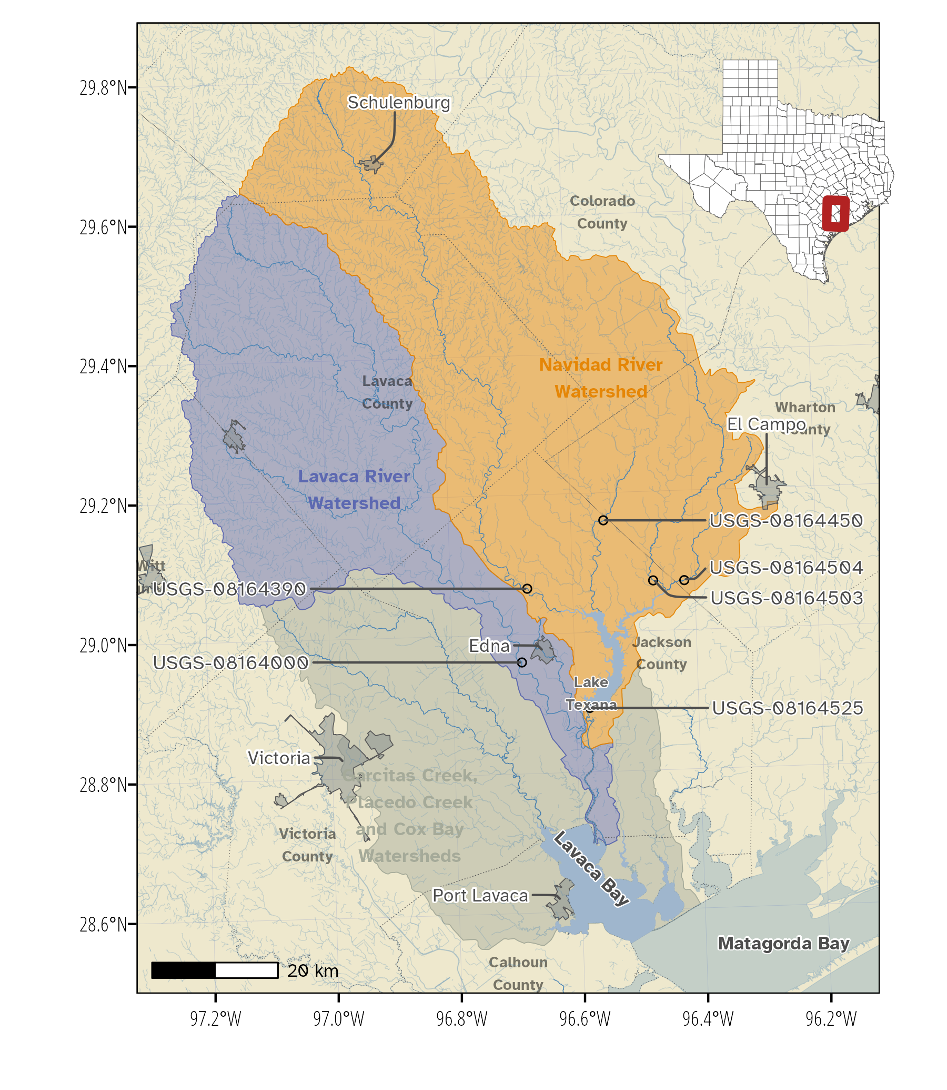

Figure . Study area map.

Table . Summary statistics for mean daily discharge, NO3-N, and TP at the freshwater sites where daily nutrient loads were estimated.

| **Site** | **Description** |  | **Mean Daily Discharge (cfs)** | |  | **NO3-N (mg/L)** | |  | **TP (mg/L)** | |
| --- | --- | --- | --- | --- | --- | --- | --- | --- | --- | --- |
|  | **Mean (SD)** | **N** |  | **Mean (SD)** | **N** |  | **Mean (SD)** | **N** |
| USGS-08164000 | Lavaca River near Edna |  | 332.78 (1667.47) | 7,671 |  | 0.18 (0.24) | 74 |  | 0.21 (0.09) | 80 |
| USGS-08164390 | Navidad River at Strane Pk. |  | 222.83 (926.18) | 7,671 |  | 0.17 (0.15) | 59 |  | 0.21 (0.09) | 77 |
| USGS-08164450 | Sandy Creek near Ganado |  | 176.63 (730.01) | 7,671 |  | 0.17 (0.17) | 56 |  | 0.21 (0.20) | 75 |
| USGS-08164503 | West Mustang Creek near Ganado |  | 144.65 (617.38) | 7,671 |  | 0.45 (0.57) | 63 |  | 0.32 (0.23) | 81 |
| USGS-08164504 | East Mustang Creek near Lousie |  | 39.58 (202.06) | 7,671 |  | 1.15 (2.52) | 61 |  | 0.40 (0.31) | 79 |
| USGS-08164525 | Lake Texana |  | 666.14 (2957.79) | 7,671 |  | 0.29 (0.26) | 62 |  | 0.20 (0.08) | 81 |

### Water Quality Data

Water quality sample data were obtained from the Texas Commission on Environmental Quality (TCEQ) Surface Water Quality Monitoring Information System (<https://www80.tceq.texas.gov/SwqmisWeb/public/crpweb.faces>). Water quality data submitted through the Surface Water Quality Monitoring Information System are required to be collected under projects with an approved Quality Assurance Project Plan (QAPP) and under sample collection and lab method procedures outlined by TCEQ’s procedures manuals (<https://www.tceq.texas.gov/waterquality/monitoring/swqm_guides.html>). The QAPP and procedures manuals ensure consistent collection and analytical methods are applied between samples collected among different entities and different projects.

Sample results for nitrite (NO2-N), NO3-N, TKN, Total Nitrogen (TN), and TP were downloaded for each stream sampling site. The temporal coverage and number of samples varied for each parameter at each site. All nutrient samples were collected under routine sampling strategies (typically quarterly monitoring with some monthly sampling at main stem sites). Under ideal situations, accurate estimation of nutrient loads would include a mix of flow-biased and random samples. However, no samples were collected under flow-biased sampling strategies. There is no absolute threshold for determining the number of samples required for accurate nutrient load estimation. Model performance will vary by site characteristics under the same sampling regime. In general, under random sampling approaches, shorter modeled time periods require higher sampling resolution compared to longer time periods (Horowitz 2003). For example, a 5-year modeling period may require monthly or bi-weekly sampling to achieve adequate performance while a 20-year modeling period may only require monthly or quarterly sampling. Although sampling error and constituent concentration-flow relationships vary by site, we assumed at minimum, monthly to bi-monthly sampling strategies would be required for accurate load estimation for periods between 5 to 10 years with lower frequency required at the load estimation period increases (Horowitz 2003; Snelder et al. 2017). Based on these criteria, we limited modeling to site-parameter combinations with at least 10 years of data and 50 samples collected after January 1, 2000. This limited load estimation to NO3-N and TP parameters at the five sampling sites in the watershed. Summary statistics of water quality data used in the analysis are show in Table .

## Nutrient Load Estimation

We developed site-specific GAMs relating NO3-N and TP to discharge and temporal covariates. We fit GAMs using the *mgcv* package in R which makes available multiple types of smooth functions with automatic smoothness estimation (Wood 2011). To model watershed NO3-N and TP loads, we fit a GAM relating constituent concentration to flow and time:

$$\begin{matrix}g\left(μ\right) & =α+f_{1}\left(ddate\right)+f_{2}\left(yday\right)+f_{3}\left(log1p\left(Q\right)\right)+f_{4}\left(ma\right)+f_{5}\left(fa\right) \\ y & ∼N\left(μ, σ^{2}\right)\end{matrix} \left(1\right)$$

where μ is the conditional expected NO3-N or TP concentration, *g()* is the log-link, *α* is the intercept, *fn()* are smoothing functions. *y* is the response variable (constituent concentration) modeled as normally distributed with mean *μ* and standard deviation *σ*. *ddate* is the date converted to decimal notation, *yday* is numeric day of year (1-366), and *log1p(Q)* is the natural log of mean daily streamflow plus 1.

Moving average (*ma*) is an exponentially smoothed moving average that attempts to incorporate the influence of prior streamflow events on concentration at the current time period. Wang et al. (2011), Kuhnert et al. (2012) and Zhang and Ball (2017) refer to this as averaged or smoothed discounted flow and demonstrated improvements in nutrient loading models by including the term. Kuhnert et al. (2012) expresses MA as

$$ma\left(δ\right)=dκ_{i−1}+\left(1−δ\right){\hat{q}}_{i−1} \text{and} κ_{i}=\sum_{m=1}^{i}{{\hat{Q}}_{m}} \left(2\right)$$

where *δ* is the discount factor (here, set equal to 0.95), *κi* is the cumulative flow (*Q*) up to the *i*th day.

Flow anomaly (*fa*) is a unitless term that represents how wet or dry the current time period is from a previous time period (Vecchia et al. 2009; Zhang and Ball 2017). Long-term flow anomaly (*ltfa*) is the streamflow over the previous year relative to the entire period and calculated as described by Zhang and Ball (2017):

$$ltfa\left(t\right)={\overset{‾}{x}}_{1 year}\left(t\right)−{\overset{‾}{x}}_{entire period} \left(3\right)$$

and the short-term flow anomaly (*stfa*) calculated as the current day flow compared to the preceding 1-month streamflow:

$$stfa\left(t\right)=x_{current day}\left(t\right)−{\overset{‾}{x}}_{1 month}\left(t\right) \left(4\right)$$

where *x* are the averages of log-transformed streamflow over the antecedent period (*1-year*, *1-month*, etc.) for time *t*.  
We used *ltfa* in NO3-N models and *stfa* in TP models based on results from Zhang and Ball (2017) demonstrating major improvements in NOx regression models that incorporated *ltfa* and moderate improvements in TP regression models that incorporated *stfa*.

The model structure was slightly altered for the Palmetto Bend Dam/Lake Texana site where daily loads are not a function of natural stream flow processes, but of dam operation procedures and nutrient concentration at the discharge point of the lake. At this location, nutrient concentrations were modeled as a function of total inflow for gaged tributaries. The *ma* and *fa* terms were also calculated based on total gaged inflow. Daily loads at the dam were calculated from the discrete daily concentration at the discharge point of the lake and corresponding reported daily discharge from the dam.

Thin-plate regression splines were used for *ddate*, *log1p(Q)*, *fa*, and *ma*. A cyclic cubic regression spline was used for *yday* to ensure the ends of the spline match (day 1 and day 366 are expected to match). First order penalties were applied to the smooths of flow-based variables which penalize departures from a flat function to help constrain extrapolations for high flow measurements. Basis dimensions smooths were adjusted after using the *gam.check* function to ensure models were not undersmoothed. Model residuals were inspected for distributional assumptions using the *gratia* package (Simpson 2022).

Left-censored data were not uncommon in this dataset. Several methods are available to account for censored data. We transformed left-censored nutrient concentrations to one-half the detection limit. Although this simple approach can introduce bias (Hornung and Reed 1990), we deemed it acceptable because high concentrations and loadings are associated with high-flow events and low-flow/low-concentration events will account for a small proportion of total loadings (McDowell et al. 2021). Initial exploration using the *cenGAM* R package (Fang 2017), which provides the Tobit I family for censored Gaussian data fit using *mgcv*, as well as censored Gamma models fit with the *brms* R package (Bürkner 2017), resulted in models that substantially overestimated nutrient concentrations relative to *mgcv* models fit with the Gamma family. Similar results have been observed in other water quality studies (Bergbusch et al. 2021).

Daily loads were estimated as the predicted concentration multiplied by the daily streamflow. Standard deviations and credible intervals from GAM models can be obtained by drawing samples from the multivariate normal posterior distribution of the fitted GAM (Wood 2006; Marra and Wood 2012; McDowell et al. 2021). Uncertainty in loads were reported as 95% credible intervals developed by drawing 1000 realizations of parameter estimates from the multivariate normal posterior distribution of the model parameters. We re-estimated the load for each realization and reported the 2.5% and 97.5% quantiles. Monthly and annual loads were calculated by summing for each respective time period.

Daily flow variability is responsible for most of daily load variability. WRTDS utilizes a flow- normalization procedure that removes the influence of flow variability by treating daily flow as a random sample of all possible discharges on a given day (Hirsch et al. 2010). The flow-normalized estimates are not true estimates of load but are indicative of potential changes in load that are not attributable to variability in daily flow. These flow-normalized estimates are most suitable for assessing changes in long-term trends. We implemented a similar procedure by setting flow-based covariates on each day of the year equal to each of the historical values for that day of the year between 2000 and 2021. The flow-normalized estimate is simply the mean of the model predictions for each day considering all flow values for that day of the year. Flow-normalized estimates and credible intervals were aggregated to annual reporting periods following procedures used for predicted actual loading.

Split-sample tests are often used to fit and validate models against some presumed independent data. Given the relatively small sample sizes and to retain model robustness, nutrient models were fit to the entire dataset (Shen et al. 2022). The modeling approach was assessed using repeated 5-fold cross validation (Burman 1989) and summarized Nash-Sutcliffe Efficiency (NSE), r2, and percent bias (PBIAS) performance metrics across folds for each model. These metrics were compared to values suggested by (Moriasi et al. 2015) as an assessment of model performance to independent data.

# Results

## Model Assessment

Individual models were generated for each site and parameter combination. Nutrient concentration model summaries (model coefficients, model metrics, and cross validation results) for each of those models are provided as tables in Appendix A. GAM models generally exhibited strong explanatory ability for NO3-N concentrations with adjusted r2 values ranging from 0.717 to 0.965 and deviance explained values ranging from 0.767 to 0.977 (Figure ). GAMs performed less well for explaining TP concentration with adjusted r2 values ranging from 0.260 to 0.757 and deviance explained values between 0.323 and 0.824.

Plots of predicted and observed NO3-N concentrations indicate high residual variance at low concentrations but very low variance at high concentrations (Figure ). The low variance at elevated NO3-N concentrations explains the high adjusted r2 and deviance explained scores which might be overly weighted by predictions at high NO3-N concentrations. In comparison, residual variance is more homogeneous with the TP models with consistent negative bias for some of the sites (Figure ).

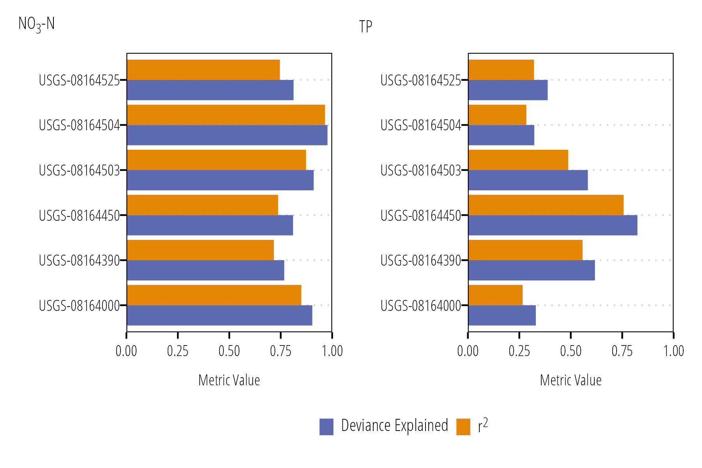

Figure . GAM model metrics (r2 and deviance explained) across each site and parameter.

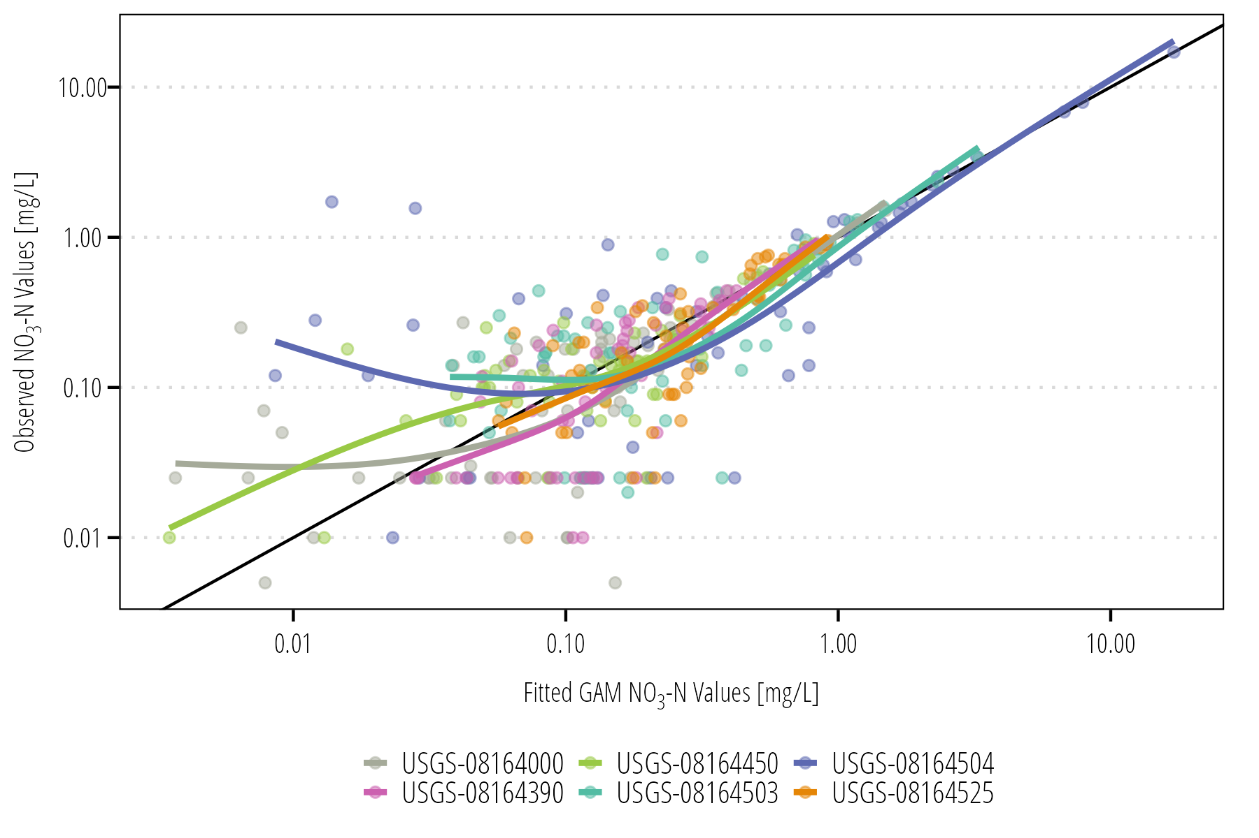

Figure . Fitted NO3-N GAM model predictions and observed measurement values across all models. The black line is a 1:1 line that indicates perfect fit. The colored lines are a smoothed fit between fitted and observed values at each site.

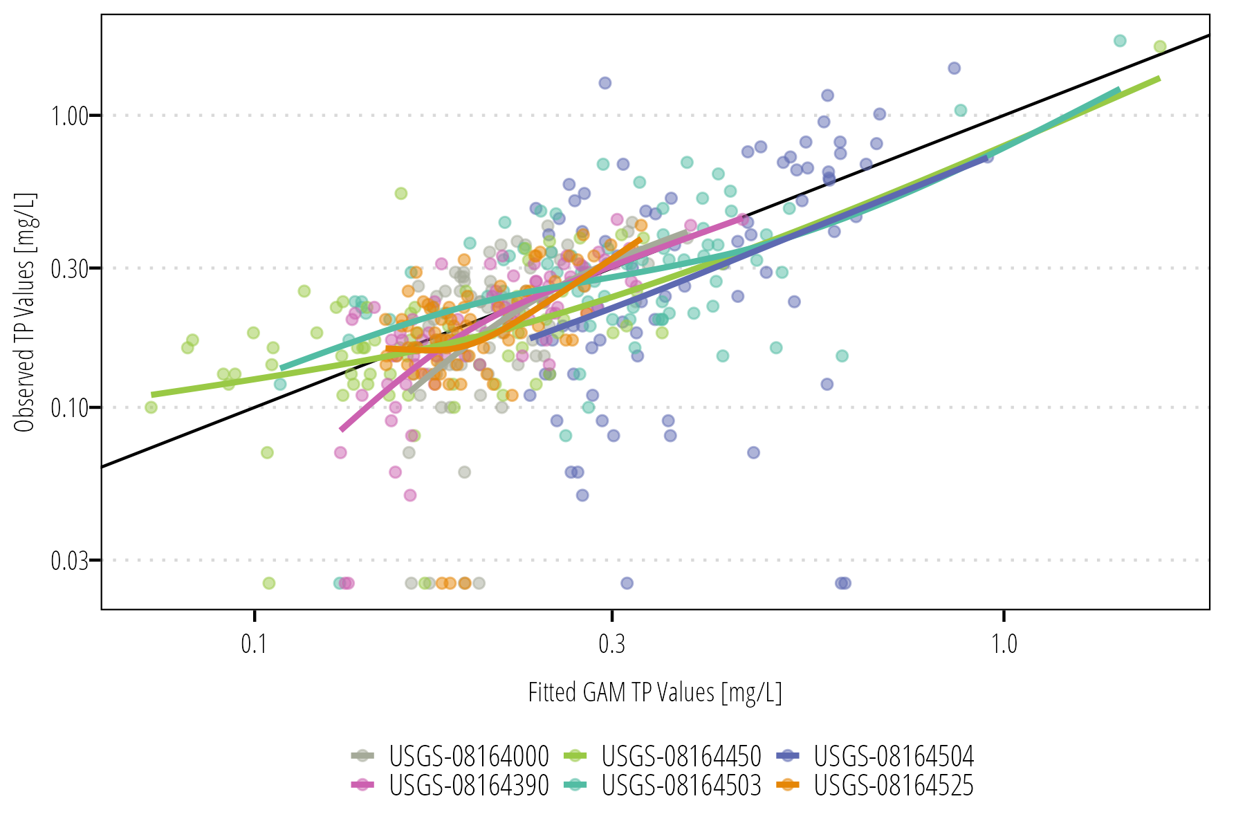

Figure . Fitted TP GAM model predictions and observed measurement values across all models. The black line is a 1:1 line that indicates perfect fit. The colored lines are a smoothed fit between fitted and observed values at each site.

Repeated 5-fold cross validation showed that GAM performance ranged from “satisfactory” to “very good” for predicating NO3-N and TP loads at the two most downstream sites (Lavaca River and Palmetto Bend Dam/Lake Texana) based evaluation criteria provided in Moriasi et al. (2015). Tables of model metric median and interquartile ranges are provided for every model in Appendix A. The distribution and tail probability of metric scores based on repeated 5-fold cross validation scores are sown in Figure . Among the site upstream of Lake Texans, cross-validation scores showed high variance, in particular for NO3-N loads. Performance of NO3-N load cross validation ranged from non-acceptable to very good. NO3-N load predictions at East Mustang Creek and Sandy Creek are notable with NSE metrics of -0.02 and 0.23 which fall in the non-acceptable range. Cross validation showed TP load predictions performed between acceptable and very good at all sites. The relatively high performance in predicting TP loads relative to predicting TP concentrations provides some evidence that changes in flows are responsible for a greater amount of variance in TP loads relative to NO3-N loads. Evidenced by the higher standard deviation (SD) in NO3-N concentrations, changes in NO3-N concentration contribute to a relatively larger amount of load variation compared to TP. This is especially apparent at Sandy Creek and East Mustang Creek (Tables , , , , , , , ).

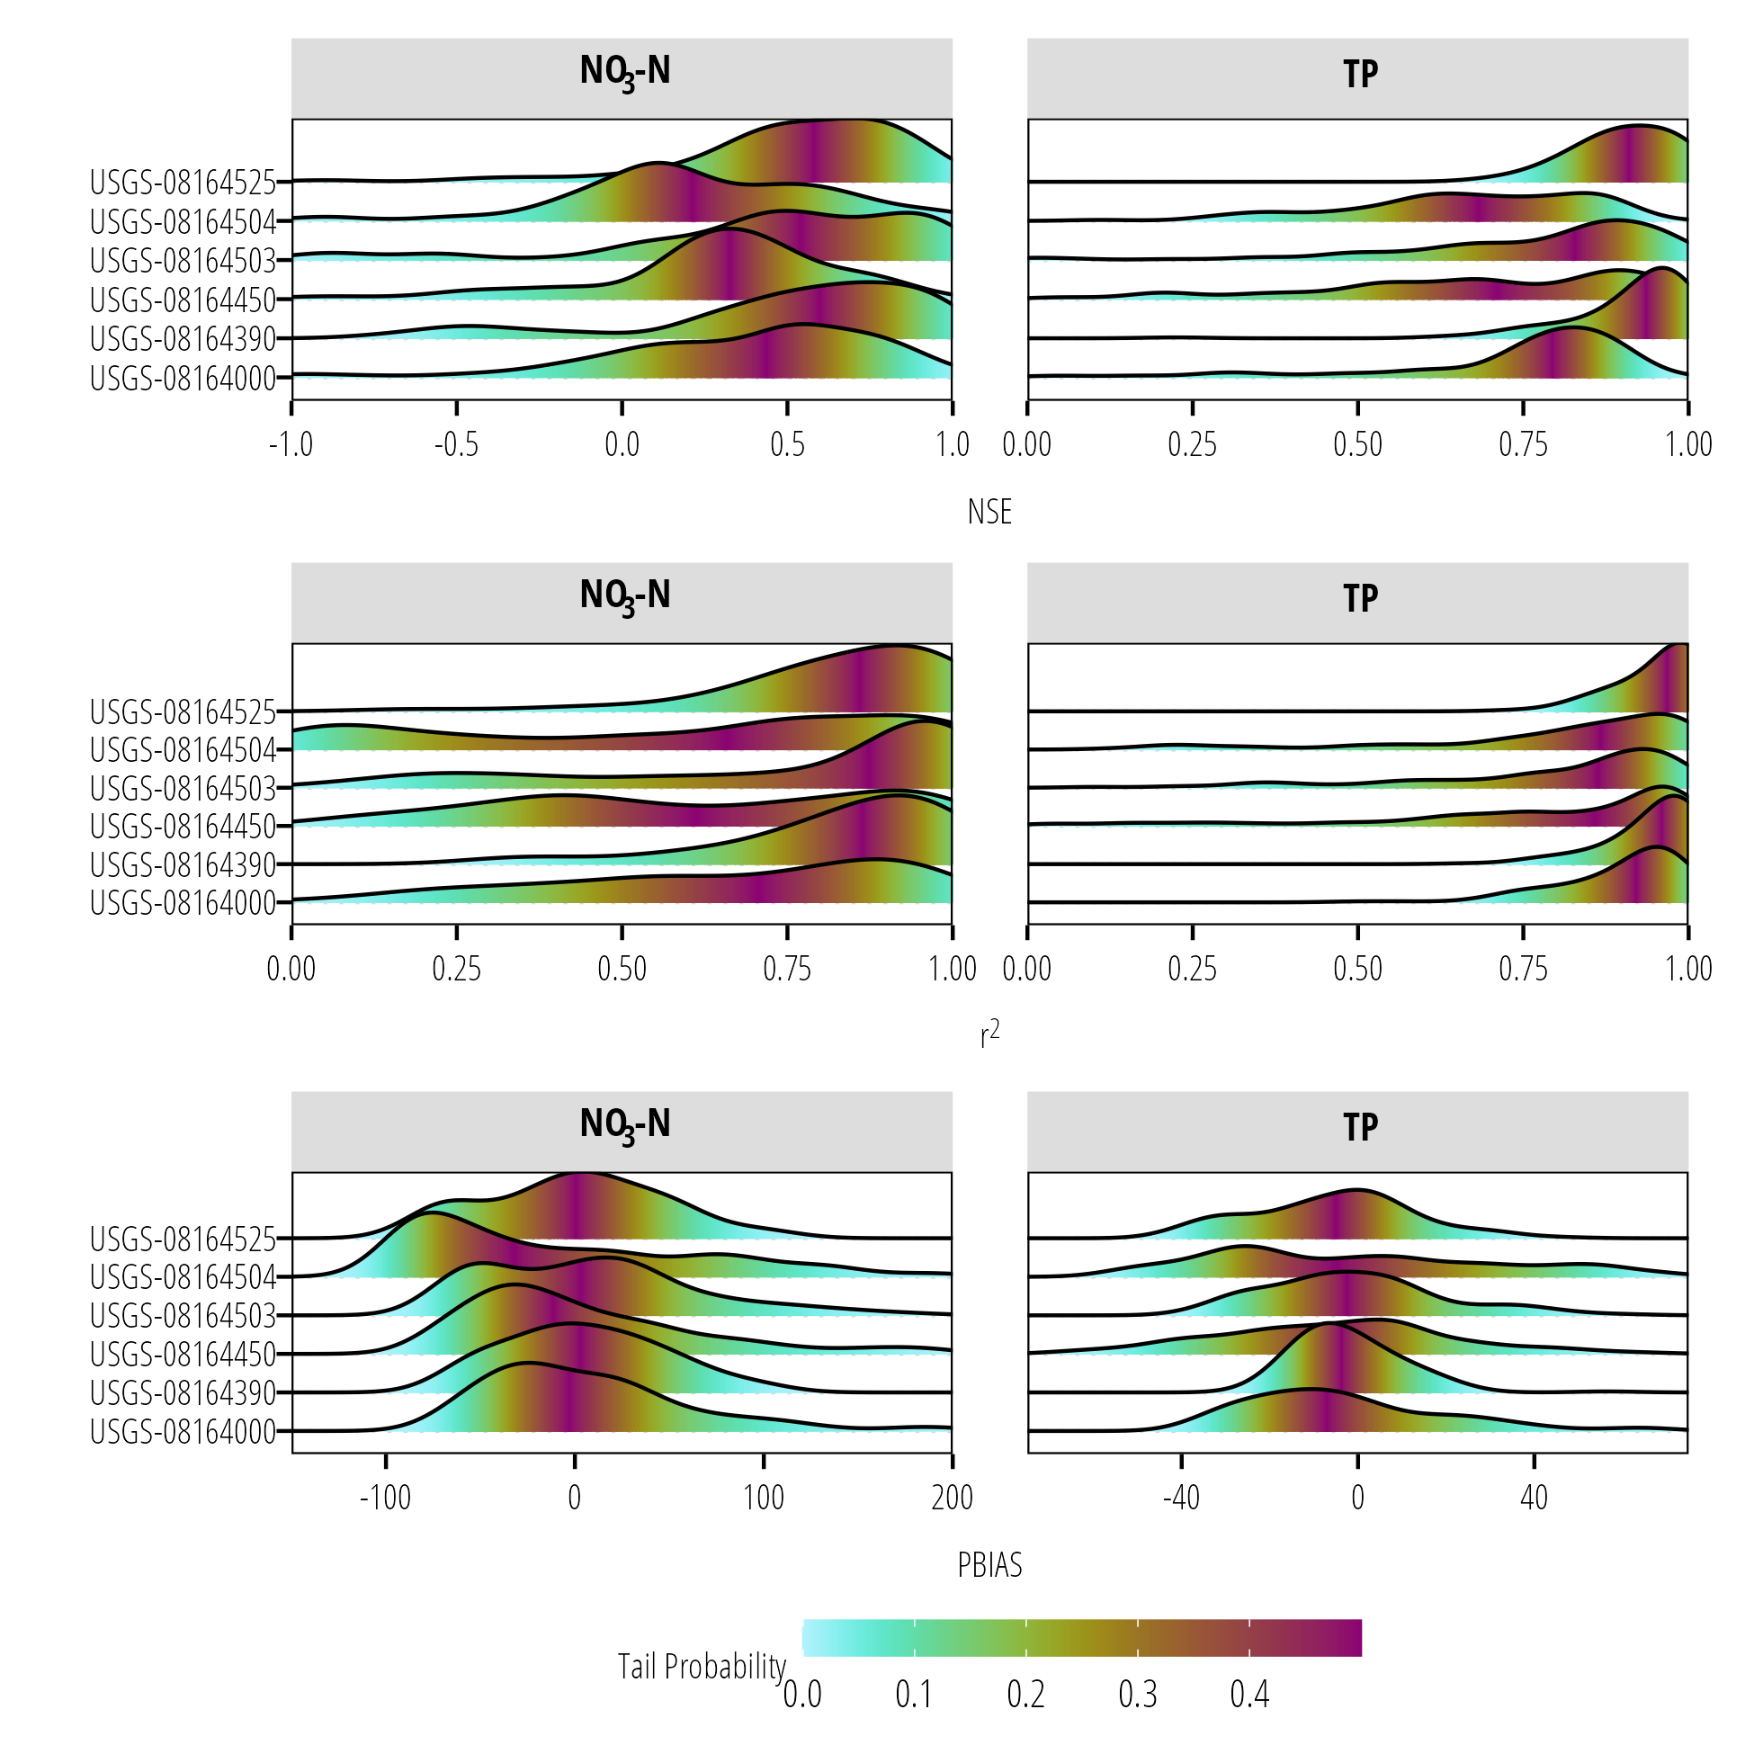

Figure . Density plots of goodness-of-fit metric results from repeated 5-fold cross-validation. Color indicates the tail probability calculated from the empirical cumulative distribution of the goodness-of-fit metrics.

## Nutrient Loads

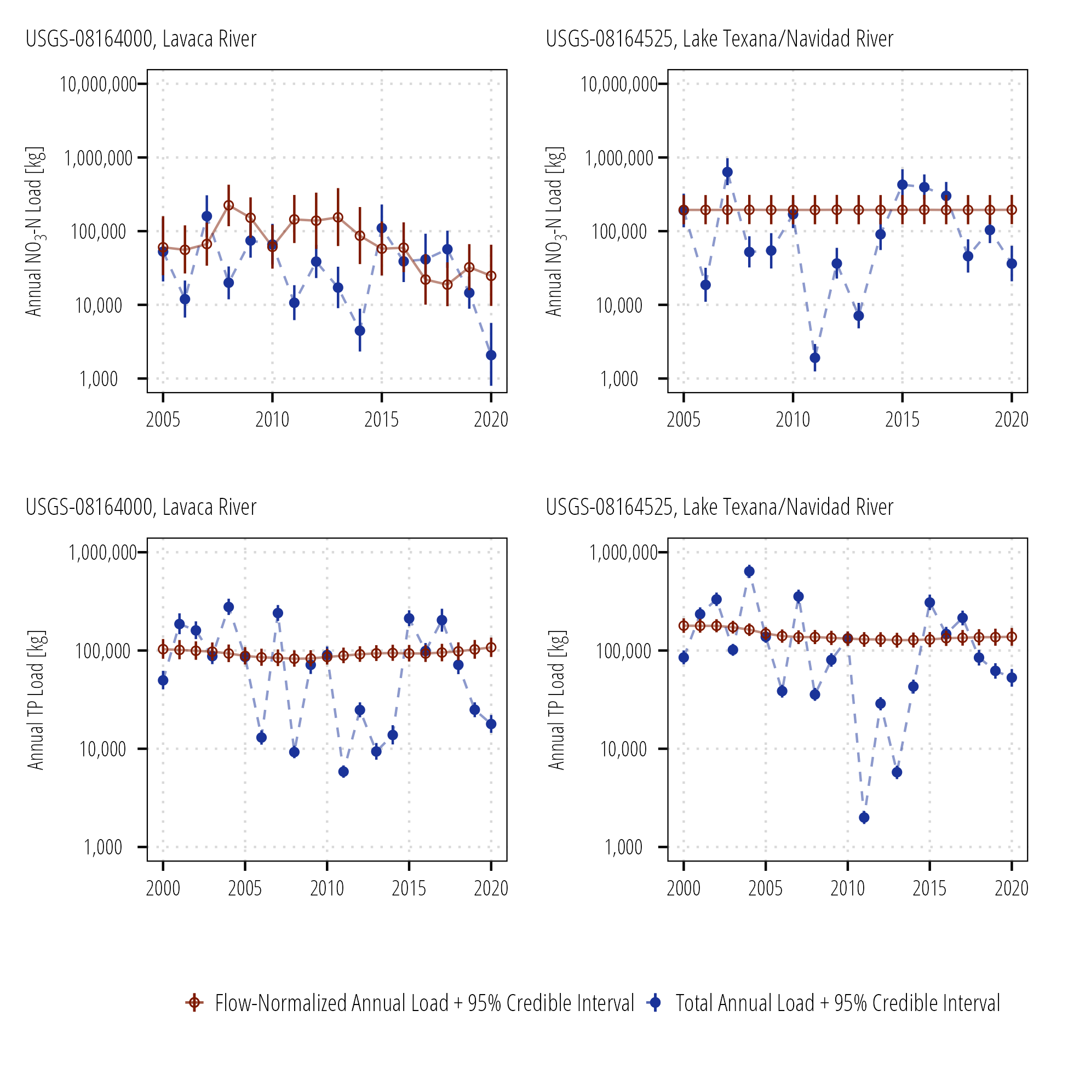

Figure . Aggregated estimated annual and flow-normalized annual NO3-N and TP loads for Lavaca River (USGS-08164000) and Lake Texana at Palmetto Bend Dam (USGS-08164525)

Appendix B includes plots of daily, monthly, and annual loads and flow-normalized loads for each site and parameter. Figure shows annual and flow-normalized annual loads with 95% credible intervals at USGS-08164000 (Lavaca River) and USGS-08164525 (Lake Texana). For both nutrient parameters, high variations in annual loads coincide with variations in annual discharge. The lowest nutrients loads were estimated in 2006, 2011, and 2013 coinciding with drought conditions in the area. Conversely, high loadings occurred in 2007, 2015, 2016, and 2017. The flow-normalized estimates of TP loads show no or small annual variation. These results are consistent with model metric results suggesting variation in flow is responsible for much of the observed variation in TP loads. Flow-normalized loads at Lavaca River indicate higher amounts of annual variation suggesting something other than flow is responsible for year-to-year changes in Lavaca River NO3-N loads. flow-normalized NO3-N loads at Lake Texana do not show any year-to-year variation. This may be due to lake processes that attenuate NO3-N concentrations and the relatively large variations observed in Lake Texana discharges that ultimately dominate the estimated NO3-N loadings.

Figures and show the deviation of flow-normalized nutrient estimates from the mean. The vertical lines indicate the 95% credible intervals of the flow-normalized estimates, and we can infer that years where the credible intervals do not overlap zero are significantly different than average. Lavaca River annual flow-normalized NO3-N loads were higher than average in 2008 and 2009 and lower than average 2017 through 2020. Overall, a 59% reduction in flow-normalized NO3-N loads were estimated from 2005 through 2020 in the Lavaca River. Conversely, no significant changes in annual flow-normalized TP loads were estimated in the Lavaca River. No significant changes were detected for annual flow-normalized NO3-N loads at Lake Texana. Annual flow-normalized TP loads at Lake Texana were significantly higher than the mean from 2000 through 2003 and we estimated a 23% reduction in flow-normalized TP loads from Lake Texana from 2000 through 2020.

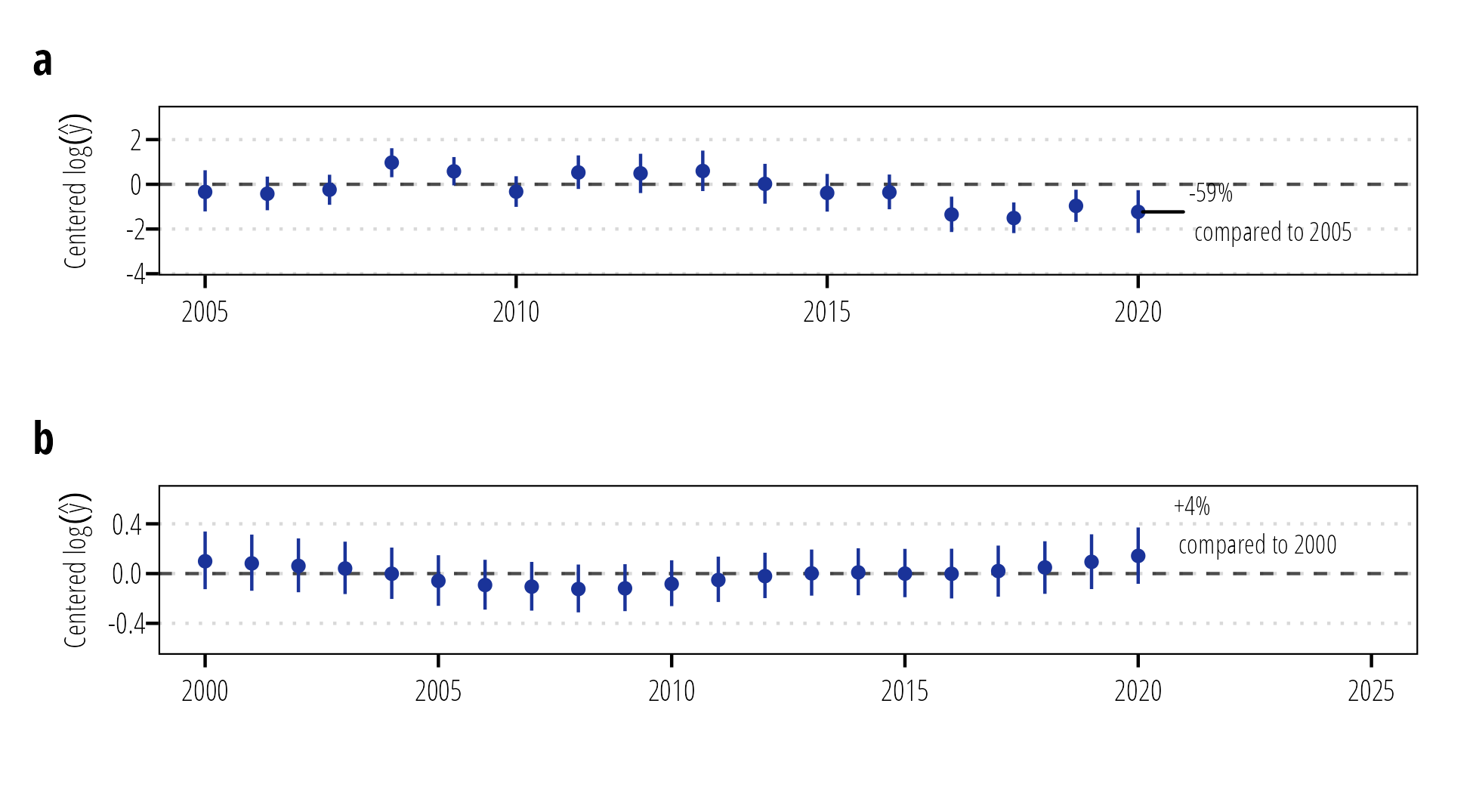

Figure . Deviation of annual log flow-normalized (a) NO3-N and (b) TP loads from the mean at Lavaca River.

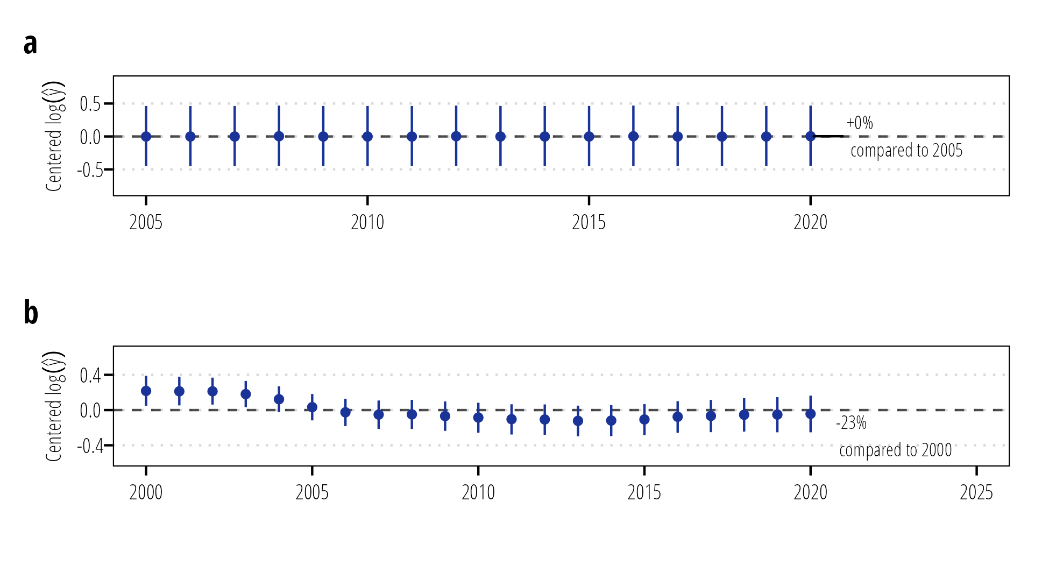

Figure . Deviation of annual log flow-normalized (a) NO3-N and (b) TP loads from the mean at Lake Texana.

Figures and show the combined NO3-N and TP loadings to Lavaca Bay as modeled at the Lavaca River and Lake Texana sites. These figures (and daily loading figures in Appendix B) show high variability in loadings that are driven by flow events. Total annual NO3-N loads ranged from 12,574 kg (95% credible intervals = 7,450 kg - 21,422 kg) in 2011 to 794,510 kg (503,865 kg - 1,284,070 kg) in 2007. The mean annual NO3-N loading from 2005 through 2020 was 205,405 kg (126,867 kg - 341,569 kg). Total annual TP loads ranged from 7,839 kg (6,780 kg - 9,083 kg) in 2011 to 916,908 kg (776,637 kg - 1,082,196 kg) in 2004. Mean annual TP loading from 2000 through 2020 was 241,681 kg (202,284 kg - 289,386 kg). On average, discharge at Lake Texana is responsible for about 74% of NO3-N loading and 60% of TP loading. However, during drought years the Lavaca River becomes the predominate source of flow and nutrient loadings to Lavaca Bay.

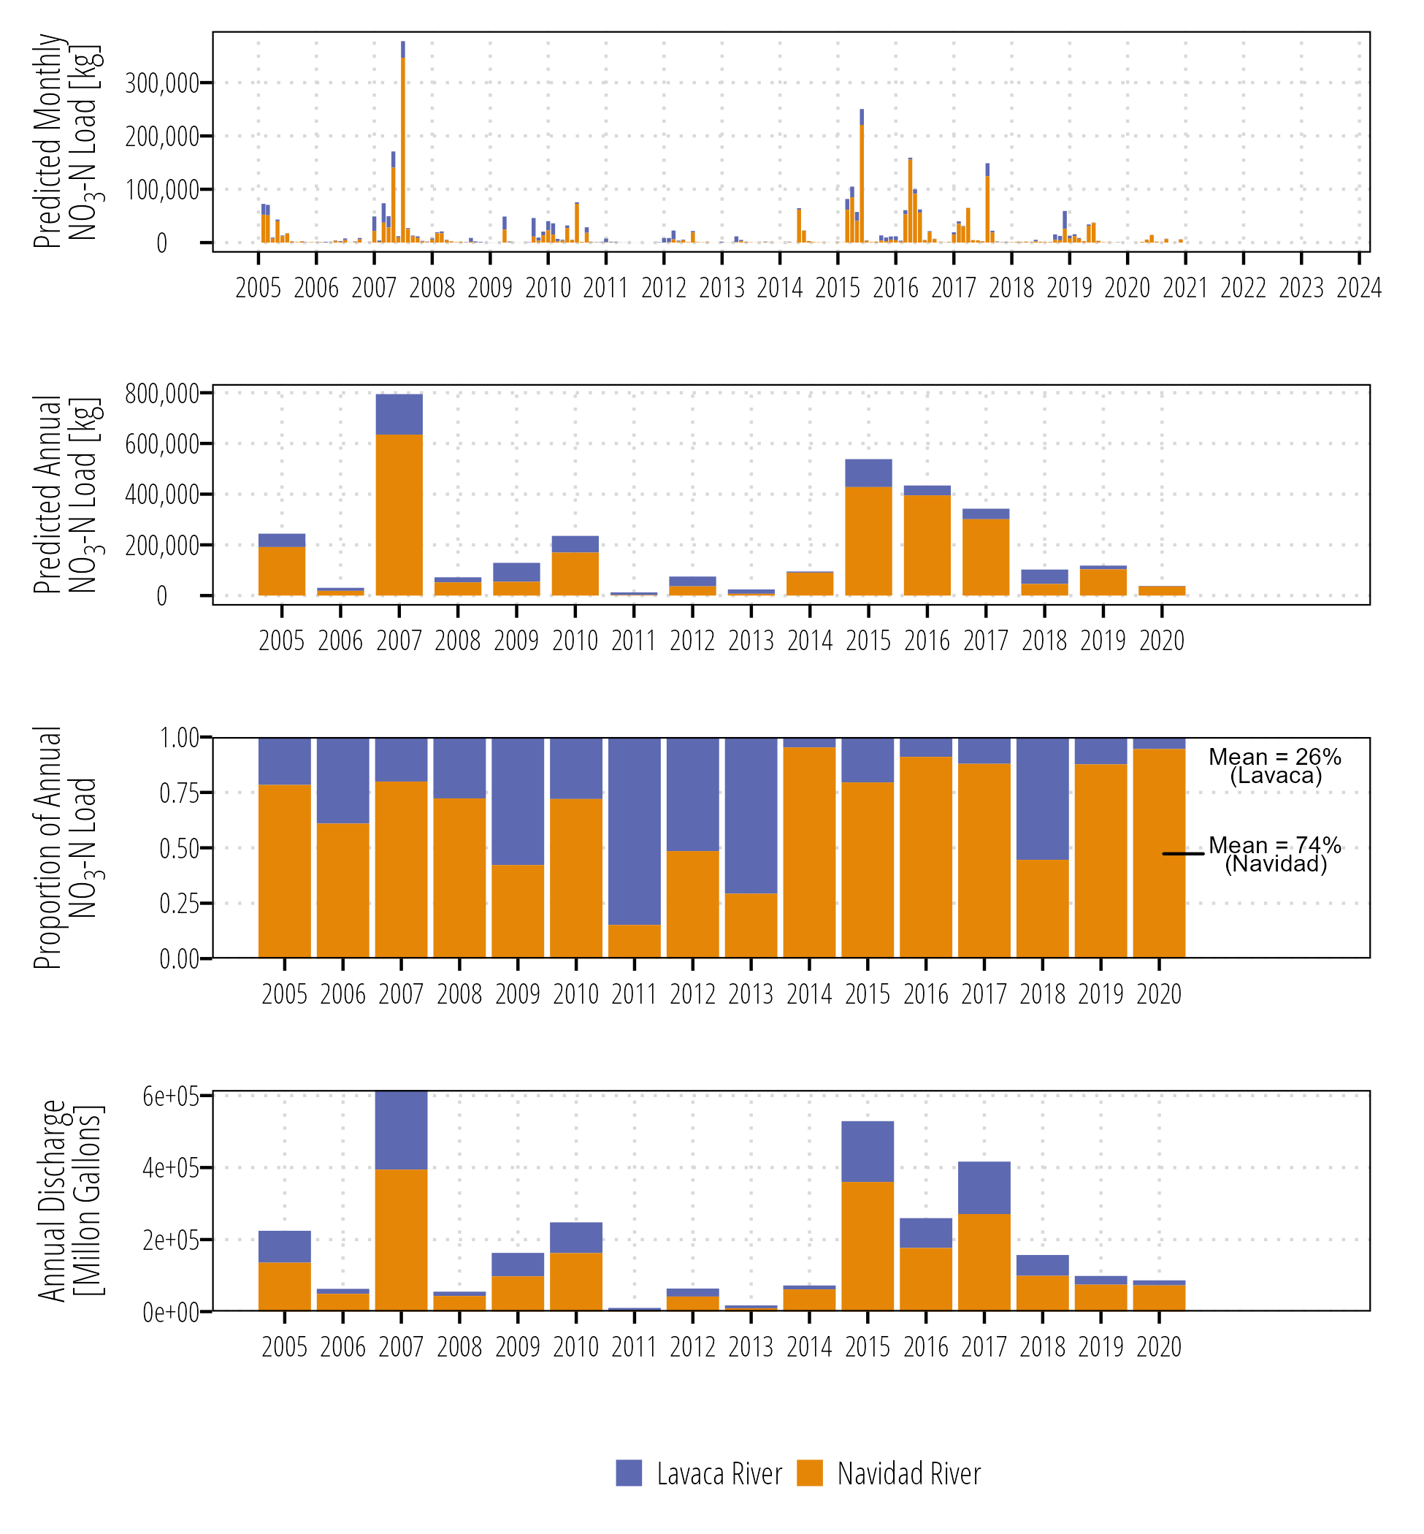

Figure . Summary of monthly and annual total delivered NO3-N loads.

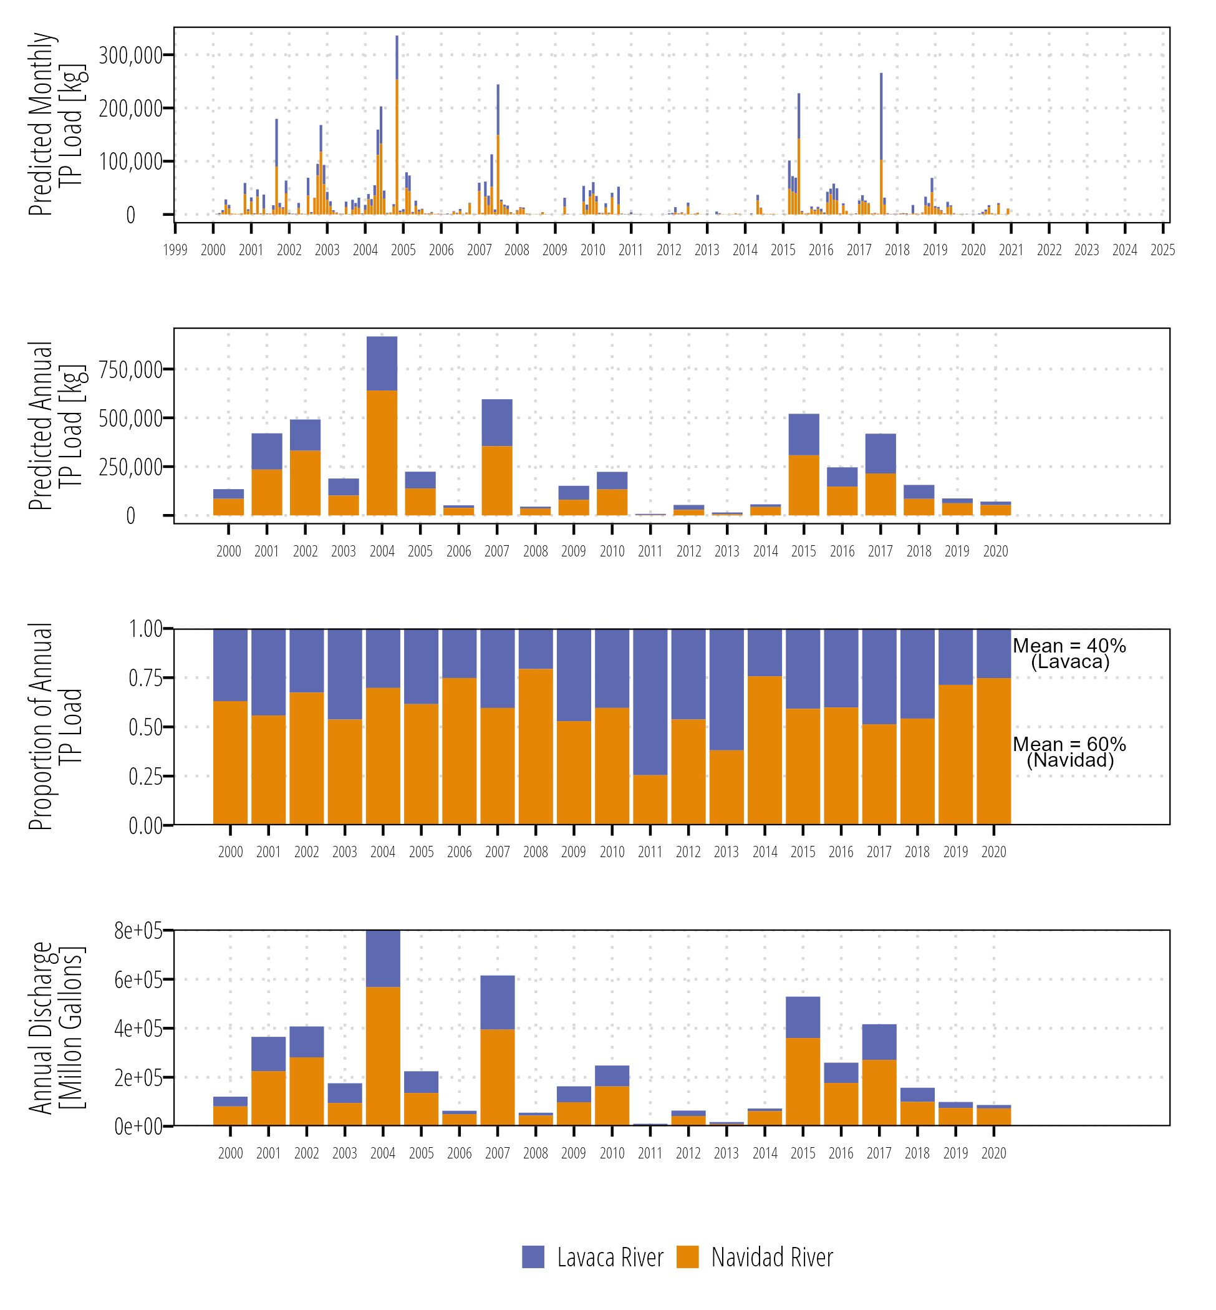

Figure . Summary of monthly and annual total delivered TP loads.

# Discussion

This study faced two primary challenges for developing reliable estimates of nutrient loads; (1) relatively sparse nutrient concentration data collected approximately quarterly, and (2) application of statistical modelling approaches at a dam discharge site. Cross validation indicated GAMs performed well for predicting observed data at the mainstem Lavaca River and Lake Texana site. In comparison to annual average yields calculated in other studies, we found our results for TP yields across the entire watershed comparable to recent studies (Table ). Wise et al. (2019) and Omani et al. (2014) use a hybrid statistical model and mechanistic approach respectively and provde very similar results that increase the confidence in the reliability of the results in the current study.

Lower model performance at sites above Lake Texana suggest that higher resolution nutrient concentration data is needed to develop reliable estimates of nutrient loads. Under some conditions the log-linear relationship between streamflow and nutrient load, that is the underlying basis of the applied statistical approach, fail in these watersheds (East Mustang Creek and Sandy Creek in particular). East Mustang Creek has two upstream wastewater discharges (although no available daily nutrient discharge data) that might elevate insteam nutrient concentrations under lower flow conditions, although not obvious relationships were discovered between quarterly reported discharges and measured instream concentration data. Compared to the Lavaca and Navidad Rivers, both East Mustang Creek and Sandy Creek watersheds are dominated by cropped agricultural fields with little riparian buffer. Timing of fertilizer applications and precipitation may also have an unaccounted influence on instream nutrient concentrations. Finally, in these smaller streams, groundwater influence at low streamflows may have another unaccounted contribution to nutrient concentrations.

Table . Nutrient yield estimated in other regional studies

| **Parameter** | **Reported Yield (kg/km2/yr)** | **Approach** | **Time Period** | **Reference** |
| --- | --- | --- | --- | --- |
| TP | 42.9 (34.4, 54.0)a | GAM | 2000-2020 |  |
| TP | 45.2 | SPARROW | 2012 | Wise et al. (2019) |
| TP | 42 | SWAT | 1977-2005 | Omani et al. (2014) |
| TP | 20.81-91.58b | SPARROW | 2002 | Rebich et al. (2011) |
| TP | 28.9 | LOADEST | 1972-1993 | Dunn (1996) |
| aValues represent the mean of annual point estimates, lower and upper 95% credible intervals. | | | | |
| bA single point estimate was not reported, these value represent the range depicted on the choropleth map provided in the report. | | | | |

The flexibility of the GAM approach allowed us to easily incorporate inflow based covariates at the Lake Texana site and antecedent discharge conditions at all sites. Model summaries (Appendix A) indicate many of these covariates provide explanatory information. Another advantage of the GAM approach is the ability to use different exponential families for the conditional response. We used the Gaussian distribution with a log link in this study based on exploratory work that found that Tobit I and censored Gamma families did not perform as well. However, due to the prevalence of left-censored data future work should investigate the use of families that accommodate censored responses not only to improve predictive ability, but to better align with best practices when utilizing censored data (Helsel 2006).

## Lavaca Bay Nutrient Loading

Both NO3-N and TP loadings show high annual, monthly, and daily variability driven by the amount of freshwater discharge in the system. Discharge as measured at the Lavaca River USGS gauge is largely unmodified and representative a fairly natural system with minimal withdrawls, wastewater contributions, or dams. Conversely, the Palmetto Bend Dam forming Lake Texana on the Navidad River is representative of a managed highly regulated system. On average, the Navidad River/Lake Texana dishcharge contribute 74% of NO3-N and 60% of TP loadings to Lavaca Bay from the Lavaca River/Navidad river system. The Lavaca and Navidad watersheds account for approximately 73% of the Lavaca Bay watershed land area. Additional nutrient contributions to Lavaca Bay from the Garcitas Creek, Placedo Creek, and Cox Bay watersheds are not accounted for due to lack of measured nutrient concentration data in those watersheds.

## Data Gaps

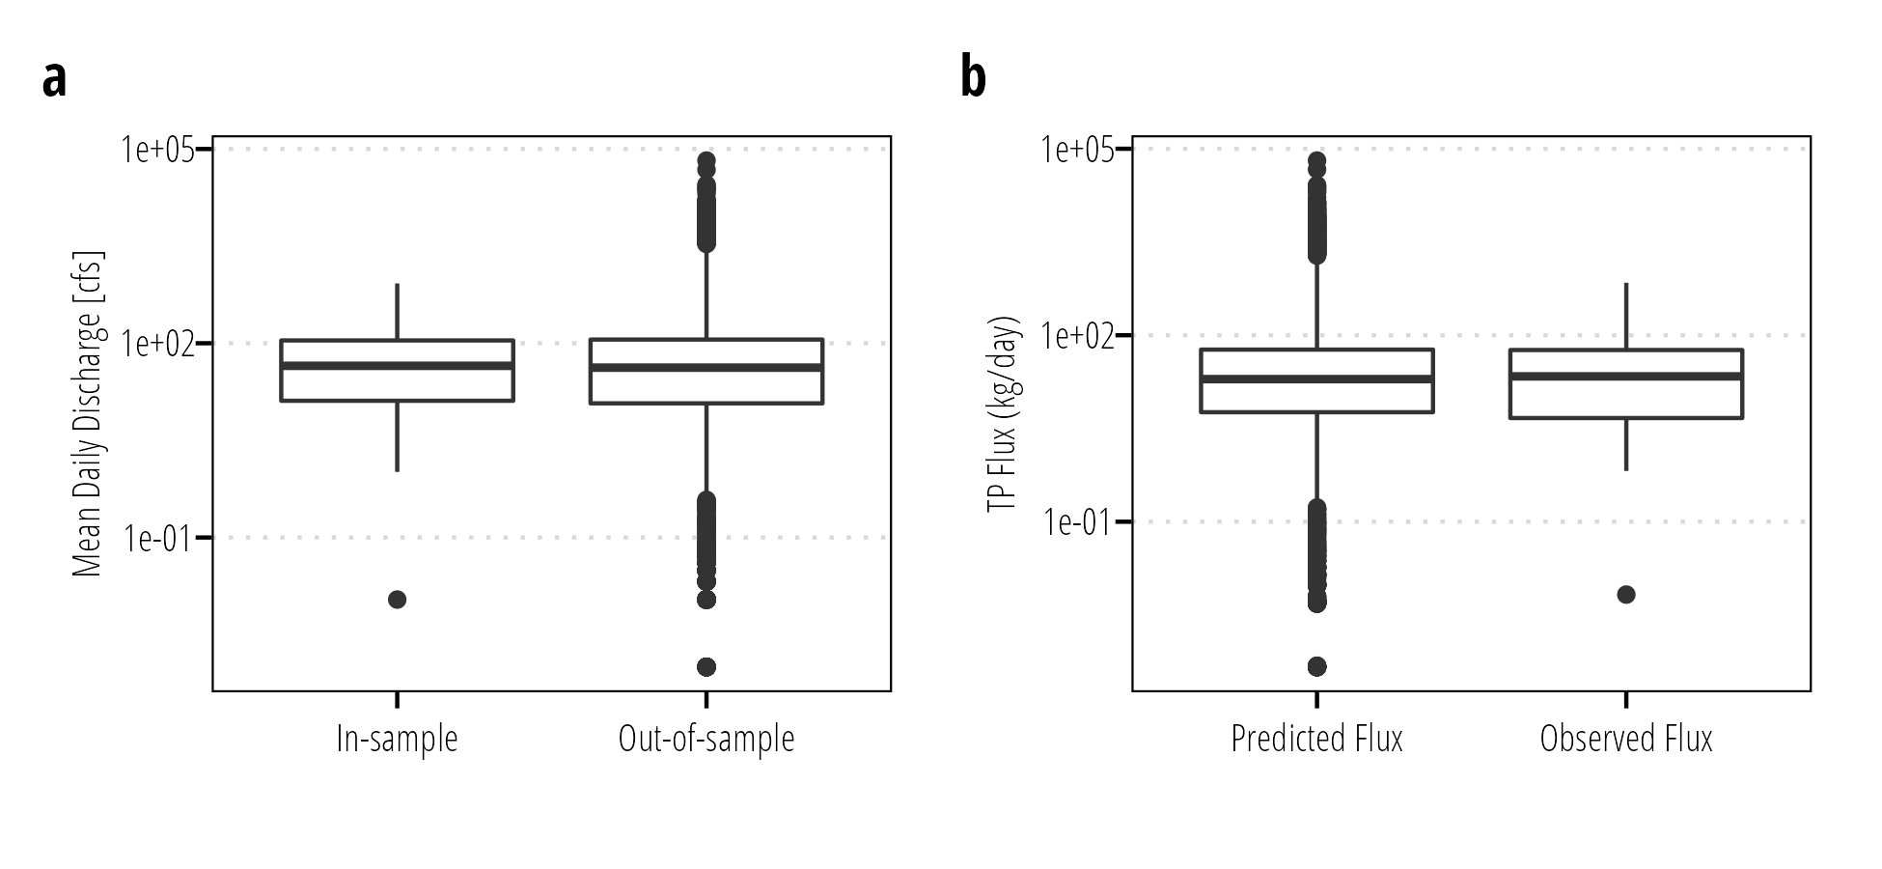

Figure . Comparisons of (a) in-sample and out-of-sample mean daily discharge and (b) predicted daily TP fluxes (for both sampled and non-sampled days) and measured daily TP fluxes at Lavaca River (USGS-08164000).

The additional 5-years of TP data result in much smaller credible intervals for TP load predictions compared to NO3-N load predictions. Under typical random sampling approaches, this is expected as sampling resolution must increase under shorter time frames to obtain equivalently accurate model results (Horowitz 2003). One method to reduce the temporal data length needed for accurate load estimations would be to supplement measured concentration data with flow-biased concentration data. Data collected under the routine monitoring procedures used for the state’s 303(d) water quality assessment program is intended to assess ambient water quality under typical conditions. Figure -a shows the distribution of streamflow represented by TP samples collected under the routine monitoring program at Lavaca River (USGS-08164000). The collected data is well representative of the median and 25th - 75th interquartile range of mean daily streamflow values at this site. This indicates monitoring data does a good job of representing median conditions.

High flow conditions are responsible for most of total nutrient loadings in watersheds. In order to develop accurate estimates of high flow loadings using regression-based approaches, supplemental flow-biased nutrient concentration data should be collected to supplement existing data. Figure -b shows the distribution of predicted daily TP flux and observed flux at Lavaca River (USGS-08164000). The distribution of observed daily fluxes shows that there are no measured observations of extreme nutrient loading events (greater than 1.5 times the 75 percentile). This makes it impossible to confirm the accuracy of important high load events. The importance of including flow-biased or storm sampling in regression-based load estimates has been confirmed by Vieux and Moreda (2003); Snelder et al. (2017); and Zhang and Ball (2017).

NO3-N represents an inorganic highly soluble form of nitrogen often associated with agricultural runoff. However, it is not the only form of nitrogen that should be considered. TN which quantifies organic and inorganic nitrogen forms as well as TKN which quantifies forms of organic nitrogen are not included in the current study because of insufficient data. Recent monitoring efforts in the watershed now include a full suite of nutrient parameters to better estimate sources, but developing load estimates from these measurements is still several years away. Developing long-term load estimates of these different forms of nitrogen will be important to linking water quality changes in Lavaca Bay to upstream land use.

# Conclusion

This project used GAMs, a statistical regression-based approach, to model nutrient concentration and streamflow relationships. The flexible nature of the approach proved useful for modeling non-linear relationships and incorporation of additional covariates that are more difficult to add using commonly available models. Using GAMs, estimates of daily, monthly, and annual NO3-N and TP loads were developed along with flow-normalized estimates that provide evidence of changes in nutrient loading normalized for changes in streamflow. Cross-validation methods were used to evaluate the performance of these models and indicate that the two main sites (Lavaca River near Edna and Lake Texana at Palmetto Bend Dam) performed well. However, performance at some of the upstream sites (East Mustang Creek and Sandy Creek in particular) was inconsistent and occasionally unacceptable for some paramter-site combinations. To develop reliable loadings estimates at smaller watersheds increased sampling frequency is required. For all sites, additional flow-biased monitoring is needed to properly characterize and evalute high-flow loading events which are responsible to the majority of loading in smaller coastal watersheds. While on-going work in these watersheds is filling gaps related to missing nutrient parameters (TN and TKN in particular) additional efforts at filling in data gaps along the range of flow conditions needs to be pursued.

# Bibliography

Beck MW, Murphy RR. 2017. Numerical and qualitative contrasts of two statistical models for water quality change in tidal waters. JAWRA Journal of the American Water Resources Association. 53(1):197–219. doi:[10.1111/1752-1688.12489](https://doi.org/10.1111/1752-1688.12489).

Bergbusch NT, Hayes NM, Simpson GL, Leavitt PR. 2021. Unexpected shift from phytoplankton to periphyton in eutrophic streams due to wastewater influx. Limnol Oceanogr. 66(7):2745–2761. doi:[10.1002/lno.11786](https://doi.org/10.1002/lno.11786).

Biagi KM, Ross CA, Oswald CJ, Sorichetti RJ, Thomas JL, Wellen CC. 2022. Novel predictors related to hysteresis and baseflow improve predictions of watershed nutrient loads: An example from Ontario’s lower Great Lakes basin. Science of The Total Environment. 826:154023. doi:[10.1016/j.scitotenv.2022.154023](https://doi.org/10.1016/j.scitotenv.2022.154023).

Bricker SB, Longstaff B, Dennison W, Jones A, Boicourt K, Wicks C, Woerner J. 2008. Effects of nutrient enrichment in the nation’s estuaries: A decade of change. Harmful Algae. 8(1):21–32. doi:[10.1016/j.hal.2008.08.028](https://doi.org/10.1016/j.hal.2008.08.028).

Bugica K, Sterba-Boatwright B, Wetz MS. 2020. Water quality trends in Texas estuaries. Marine Pollution Bulletin. 152:110903. doi:[10.1016/j.marpolbul.2020.110903](https://doi.org/10.1016/j.marpolbul.2020.110903).

Bürkner P-C. 2017. **brms** : An *R* Package for Bayesian Multilevel Models Using *Stan*. J Stat Soft. 80(1). doi:[10.18637/jss.v080.i01](https://doi.org/10.18637/jss.v080.i01).

Burman P. 1989. A comparative study of ordinary cross-validation, v-fold cross-validation and the repeated learning-testing methods. Biometrika. 76(3):503–514. doi:[10.1093/biomet/76.3.503](https://doi.org/10.1093/biomet/76.3.503).

Cohn TA, Caulder DL, Gilroy EJ, Zynjuk LD, Summers RM. 1992. The validity of a simple statistical model for estimating fluvial constituent loads: An Empirical study involving nutrient loads entering Chesapeake Bay. Water Resour Res. 28(9):2353–2363. doi:[10.1029/92WR01008](https://doi.org/10.1029/92WR01008).

De Cicco LA, Hirsch RM, Lorenz DL, Watkins WD, Johnson M. 2022. dataRetrieval: R packages for discovering and retrieving water data available from Federal hydrologic web services. doi:[10.5066/P9X4L3GE](https://doi.org/10.5066/P9X4L3GE). <https://code.usgs.gov/water/dataRetrieval>.

Dunn D. 1996. Trends in nutrient inflows to the Gulf of Mexico from streams draining the conterminous United States, 1972-93. Austin, Texas: USGS Report No.: 96-4113. <http://pubs.er.usgs.gov/publication/wri964113>.

Fang Z. 2017. cenGAM: Censored Regression with Smooth Terms. <https://CRAN.R-project.org/package=cenGAM>.

Hagemann M, Asce SM, Kim D, Park MH. 2016. Estimating nutrient and organic carbon loads to water-supply reservoir using semiparametric models. J Environ Eng.:9. doi:[10.1061/(ASCE)EE.1943-7870.0001077](https://doi.org/10.1061/(ASCE)EE.1943-7870.0001077).

Helsel DR. 2006. Fabricating data: How substituting values for nondetects can ruin results, and what can be done about it. Chemosphere. 65(11):2434–2439. doi:[10.1016/j.chemosphere.2006.04.051](https://doi.org/10.1016/j.chemosphere.2006.04.051).

Hirsch RM, Moyer DL, Archfield SA. 2010. Weighted Regressions on Time, Discharge, and Season (WRTDS), with an application to Chesapeake Bay river inputs. JAWRA Journal of the American Water Resources Association. 46(5):857–880. doi:[10.1111/j.1752-1688.2010.00482.x](https://doi.org/10.1111/j.1752-1688.2010.00482.x).

Hornung RW, Reed LD. 1990. Estimation of average concentration in the presence of nondetectable values. Applied Occupational and Environmental Hygiene. 5(1):46–51. doi:[10.1080/1047322X.1990.10389587](https://doi.org/10.1080/1047322X.1990.10389587).

Horowitz AJ. 2003. An evaluation of sediment rating curves for estimating suspended sediment concentrations for subsequent flux calculations. Hydrol Process. 17(17):3387–3409. doi:[10.1002/hyp.1299](https://doi.org/10.1002/hyp.1299).

Kroon FJ, Kuhnert PM, Henderson BL, Wilkinson SN, Kinsey-Henderson A, Abbott B, Brodie JE, Turner RDR. 2012. River loads of suspended solids, nitrogen, phosphorus and herbicides delivered to the Great Barrier Reef lagoon. Marine Pollution Bulletin. 65(4-9):167–181. doi:[10.1016/j.marpolbul.2011.10.018](https://doi.org/10.1016/j.marpolbul.2011.10.018).

Kuhnert PM, Henderson BL, Lewis SE, Bainbridge ZT, Wilkinson SN, Brodie JE. 2012. Quantifying total suspended sediment export from the Burdekin River catchment using the loads regression estimator tool: Regression Estimator Tool for Pollutant Loads. Water Resour Res. 48(4). doi:[10.1029/2011WR011080](https://doi.org/10.1029/2011WR011080).

Marra G, Wood SN. 2012. Coverage Properties of Confidence Intervals for Generalized Additive Model Components: Coverage properties of GAM intervals. Scandinavian Journal of Statistics. 39(1):53–74. doi:[10.1111/j.1467-9469.2011.00760.x](https://doi.org/10.1111/j.1467-9469.2011.00760.x).

McDowell RW, Simpson ZP, Ausseil AG, Etheridge Z, Law R. 2021. The implications of lag times between nitrate leaching losses and riverine loads for water quality policy. Sci Rep. 11(1):16450. doi:[10.1038/s41598-021-95302-1](https://doi.org/10.1038/s41598-021-95302-1).

Moriasi DN, Gitau MW, Pai N, Daggupati P. 2015. Hydrologic and water quality models: Performance measures and evaluation criteria. Trans ASABE. 58(6):1763–1785. doi:[10.13031/trans.58.10715](https://doi.org/10.13031/trans.58.10715).

Omani N, Srinivasan R, Lee T. 2014. Estimation of Sediment and Nutrient Loads to Bays from Gauged and Ungauged Watersheds. Appl Eng Agric.:869–887. doi:[10.13031/aea.30.10162](https://doi.org/10.13031/aea.30.10162).

Rebich RA, Houston NA, Mize SV, Pearson DK, Ging PB, Evan Hornig C. 2011. Sources and delivery of nutrients to the Northwestern Gulf of Mexico from streams in the South-Central United States. JAWRA Journal of the American Water Resources Association. 47(5):1061–1086. doi:[10.1111/j.1752-1688.2011.00583.x](https://doi.org/10.1111/j.1752-1688.2011.00583.x).

Robson BJ, Dourdet V. 2015. Prediction of sediment, particulate nutrient and dissolved nutrient concentrations in a dry tropical river to provide input to a mechanistic coastal water quality model. Environmental Modelling & Software. 63:97–108. doi:[10.1016/j.envsoft.2014.08.009](https://doi.org/10.1016/j.envsoft.2014.08.009).

Schoenbaechler C, Guthrie C, Lu Q. 2011. Coastal Hydrology for the Lavaca-Colorado Estuary. Austin, TX: Texas Water Development Board. <https://www.twdb.texas.gov/surfacewater/bays/coastal_hydrology/doc/TWDB_Matagorda_Hydrology_20110211.pdf>.

Shen H, Tolson BA, Mai J. 2022. Time to update the split‐sample approach in hydrological model calibration. Water Resources Research. 58(3). doi:[10.1029/2021WR031523](https://doi.org/10.1029/2021WR031523).

Simpson GL. 2022. gratia: Graceful Graceful ggplot-Based Graphics and Other Functions for GAMs Fitted using mgcv. <https://gavinsimpson.github.io/gratia/>.

Snelder TH, McDowell RW, Fraser CE. 2017. Estimation of catchment nutrient loads in New Zealand using monthly water quality monitoring data. J Am Water Resour Assoc. 53(1):158–178. doi:[10.1111/1752-1688.12492](https://doi.org/10.1111/1752-1688.12492).

Vecchia AV, Gilliom RJ, Sullivan DJ, Lorenz DL, Martin JD. 2009. Trends in concentrations and use of agricultural herbicides for Corn Belt Rivers, 1996−2006. Environ Sci Technol. 43(24):9096–9102. doi:[10.1021/es902122j](https://doi.org/10.1021/es902122j).

Vieux BE, Moreda FG. 2003. Nutrient loading assessment in the Illinois River using a synthetic approach. J Am Water Resources Assoc. 39(4):757–769. doi:[10.1111/j.1752-1688.2003.tb04403.x](https://doi.org/10.1111/j.1752-1688.2003.tb04403.x).

Wang Y-G, Kuhnert P, Henderson B. 2011. Load estimation with uncertainties from opportunistic sampling data – A semiparametric approach. Journal of Hydrology. 396(1-2):148–157. doi:[10.1016/j.jhydrol.2010.11.003](https://doi.org/10.1016/j.jhydrol.2010.11.003).

Wise DR, Anning DW, Miller OW. 2019. Spatially referenced models of streamflow and nitrogen, phosphorus, and suspended-sediment transport in streams of the southwestern United States. Reston, Virginia: U.S. Geological Survey Report No.: 2019-5106. <https://doi.org/10.3133/sir20195106>.

Wood SN. 2006. On confidence intervals for generalized additive models based on penalized regression splines. Aust N Z J Stat. 48(4):445–464. doi:[10.1111/j.1467-842X.2006.00450.x](https://doi.org/10.1111/j.1467-842X.2006.00450.x).

Wood SN. 2011. Fast stable restricted maximum likelihood and marginal likelihood estimation of semiparametric generalized linear models: Estimation of Semiparametric Generalized Linear Models. Journal of the Royal Statistical Society: Series B (Statistical Methodology). 73(1):3–36. doi:[10.1111/j.1467-9868.2010.00749.x](https://doi.org/10.1111/j.1467-9868.2010.00749.x).

Zhang Q, Ball WP. 2017. Improving riverine constituent concentration and flux estimation by accounting for antecedent discharge conditions. Journal of Hydrology. 547:387–402. doi:[10.1016/j.jhydrol.2016.12.052](https://doi.org/10.1016/j.jhydrol.2016.12.052).

# Appendix A: Model Assessment Results

GAM model summaries and cross-validation results for all models are shown below (Tables - ). GAM model summaries report smoothness selection for model parameters, approximate p-values of smoothed parameters, deviance explained (the proportion of the null deviance explained by the model), and model adjusted r2 (proportion of variance explained) of the final full fitted GAM model. Cross-validation tables report the median and interquartile range of NSE, R2, and PBIAS of measured and predicted loads across all cross validation folds.

## Lavaca River Near Edna, USGS-08164000

Table . Lavaca River (USGS-08164000) GAM summary for NO3-N.

| **Component** | **Term** | **Estimate** | **Std Error** | **t-value** | **p-value** |  |
| --- | --- | --- | --- | --- | --- | --- |
| A. parametric coefficients | (Intercept) | -2.346 | 0.152 | -15.390 | 0.0000 | *** |
| **Component** | **Term** | **edf** | **Ref. df** | **F-value** | **p-value** |  |
| B. smooth terms | s(ddate) | 10.465 | 17.000 | 4.598 | 0.0000 | *** |
| s(yday) | 2.400 | 4.000 | 6.578 | 0.0000 | *** |
| s(log1p_Flow) | 5.968 | 9.000 | 4.521 | 0.0000 | *** |
| s(ma) | 0.003 | 9.000 | 0.000 | 0.3332 |  |
| s(ltfa) | 7.144 | 9.000 | 6.180 | 0.0000 | *** |
| Signif. codes: 0 <= '***' < 0.001 < '**' < 0.01 < '*' < 0.05 | | | | | | |
|  | | | | | | |
| Adjusted R-squared: 0.850, Deviance explained 0.903 | | | | | | |
| -REML : -28.133, Scale est: 0.00876, N: 74 | | | | | | |

Table . Summary of goodness-of-fit metrics for 5-fold cross validation of NO3-N GAM at Lavaca River near Edna (USGS-08164000).

| **Goodness of Fit Metric** | **Median (IQR)** |
| --- | --- |
| NSE | 0.34 (-0.06, 0.61) |
| R2 | 0.70 (0.49, 0.89) |
| PBIAS | 2.00 (-30.60, 33.90) |

Table . Lavaca River (USGS-08164000) GAM summary for TP.

| **Component** | **Term** | **Estimate** | **Std Error** | **t-value** | **p-value** |  |
| --- | --- | --- | --- | --- | --- | --- |
| A. parametric coefficients | (Intercept) | -1.581 | 0.044 | -35.749 | 0.0000 | *** |
| **Component** | **Term** | **edf** | **Ref. df** | **F-value** | **p-value** |  |
| B. smooth terms | s(ddate) | 3.140 | 17.000 | 0.346 | 0.0834 | . |
| s(yday) | 0.845 | 8.000 | 0.173 | 0.1847 |  |
| s(log1p_Flow) | 0.000 | 4.000 | 0.000 | 0.4413 |  |
| s(ma) | 0.000 | 5.000 | 0.000 | 0.5359 |  |
| s(stfa) | 3.012 | 4.000 | 6.167 | 0.0000 | *** |
| Signif. codes: 0 <= '***' < 0.001 < '**' < 0.01 < '*' < 0.05 | | | | | | |
|  | | | | | | |
| Adjusted R-squared: 0.266, Deviance explained 0.330 | | | | | | |
| -REML : -80.284, Scale est: 0.00644, N: 80 | | | | | | |

Table . Summary of goodness-of-fit metrics for 5-fold cross validation of TP GAM at Lavaca River near Edna (USGS-08164000).

| **Goodness of Fit Metric** | **Median (IQR)** |
| --- | --- |
| NSE | 0.80 (0.72, 0.86) |
| R2 | 0.93 (0.85, 0.97) |
| PBIAS | -7.20 (-19.90, 8.90) |

## Lake Texana near Edna, USGS-08164525

Table . Lake Texana at Palmetto Bend Dam (USGS-08164525) GAM summary for NO3-N.

| **Component** | **Term** | **Estimate** | **Std Error** | **t-value** | **p-value** |  |
| --- | --- | --- | --- | --- | --- | --- |
| A. parametric coefficients | (Intercept) | -1.450 | 0.087 | -16.634 | 0.0000 | *** |
| **Component** | **Term** | **edf** | **Ref. df** | **F-value** | **p-value** |  |
| B. smooth terms | s(ddate) | 0.000 | 9.000 | 0.000 | 0.7788 |  |
| s(yday) | 2.836 | 8.000 | 5.179 | 0.0000 | *** |
| s(log1p_inflow) | 0.000 | 4.000 | 0.000 | 0.4670 |  |
| s(log1p_Flow) | 6.058 | 9.000 | 2.712 | 0.0004 | *** |
| s(ma) | 2.665 | 5.000 | 2.101 | 0.0022 | ** |
| s(ltfa) | 4.781 | 9.000 | 3.193 | 0.0000 | *** |
| Signif. codes: 0 <= '***' < 0.001 < '**' < 0.01 < '*' < 0.05 | | | | | | |
|  | | | | | | |
| Adjusted R-squared: 0.746, Deviance explained 0.812 | | | | | | |
| -REML : -15.004, Scale est: 0.017, N: 62 | | | | | | |

Table . Summary of goodness-of-fit metrics for 5-fold cross validation of NO3-N GAM at Lake Texana at Palmetto Bend Dam (USGS-08164525).

| **Goodness of Fit Metric** | **Median (IQR)** |
| --- | --- |
| NSE | 0.48 (0.08, 0.74) |
| R2 | 0.87 (0.76, 0.95) |
| PBIAS | 10.90 (-23.90, 56.30) |

Table . Lake Texana at Palmetto Bend Dam (USGS-08164525) GAM summary for TP.

| **Component** | **Term** | **Estimate** | **Std Error** | **t-value** | **p-value** |  |
| --- | --- | --- | --- | --- | --- | --- |
| A. parametric coefficients | (Intercept) | -1.624 | 0.037 | -44.377 | 0.0000 | *** |
| **Component** | **Term** | **edf** | **Ref. df** | **F-value** | **p-value** |  |
| B. smooth terms | s(ddate) | 3.214 | 8.000 | 1.862 | 0.0009 | *** |
| s(yday) | 1.309 | 8.000 | 0.374 | 0.0879 | . |
| s(log1p_inflow) | 0.003 | 9.000 | 0.000 | 0.3600 |  |
| s(log1p_Flow) | 1.104 | 4.000 | 0.561 | 0.0982 | . |
| s(stfa) | 0.000 | 5.000 | 0.000 | 0.4699 |  |
| s(ma) | 2.262 | 5.000 | 1.669 | 0.0060 | ** |
| Signif. codes: 0 <= '***' < 0.001 < '**' < 0.01 < '*' < 0.05 | | | | | | |
|  | | | | | | |
| Adjusted R-squared: 0.321, Deviance explained 0.388 | | | | | | |
| -REML : -99.963, Scale est: 0.00403, N: 81 | | | | | | |

Table . Summary of goodness-of-fit metrics for 5-fold cross validation of TP GAM at Lake Texana at Palmetto Bend Dam (USGS-08164525).

| **Goodness of Fit Metric** | **Median (IQR)** |
| --- | --- |
| NSE | 0.91 (0.86, 0.97) |
| R2 | 0.99 (0.92, 1.00) |
| PBIAS | -3.30 (-16.40, 4.90) |

## Navidad River at Strane Pk near Edna, USGS-08164390

Table . Navidad River at Strane Pk near Edna (USGS-08164390) GAM summary for NO3-N.

| **Component** | **Term** | **Estimate** | **Std Error** | **t-value** | **p-value** |  |
| --- | --- | --- | --- | --- | --- | --- |
| A. parametric coefficients | (Intercept) | -2.037 | 0.102 | -20.057 | 0.0000 | *** |
| **Component** | **Term** | **edf** | **Ref. df** | **F-value** | **p-value** |  |
| B. smooth terms | s(ddate) | 1.685 | 17.000 | 0.781 | 0.0007 | *** |
| s(yday) | 2.486 | 4.000 | 5.143 | 0.0001 | *** |
| s(log1p_Flow) | 4.072 | 5.000 | 11.579 | 0.0000 | *** |
| s(ma) | 2.227 | 4.000 | 3.098 | 0.0010 | ** |
| s(ltfa) | 0.001 | 9.000 | 0.000 | 0.3874 |  |
| Signif. codes: 0 <= '***' < 0.001 < '**' < 0.01 < '*' < 0.05 | | | | | | |
|  | | | | | | |
| Adjusted R-squared: 0.717, Deviance explained 0.767 | | | | | | |
| -REML : -46.034, Scale est: 0.00733, N: 59 | | | | | | |

Table . Summary of goodness-of-fit metrics for 5-fold cross validation of NO3-N GAM at Navidad River at Strane Pk near Edna (USGS-08164390).

| **Goodness of Fit Metric** | **Median (IQR)** |
| --- | --- |
| NSE | 0.55 (0.25, 0.79) |
| R2 | 0.88 (0.77, 0.96) |
| PBIAS | 1.10 (-20.70, 32.70) |

Table . Navidad River at Strane Pk near Edna (USGS-08164390) GAM summary for TP.

| **Component** | **Term** | **Estimate** | **Std Error** | **t-value** | **p-value** |  |
| --- | --- | --- | --- | --- | --- | --- |
| A. parametric coefficients | (Intercept) | -1.567 | 0.034 | -45.461 | 0.0000 | *** |
| **Component** | **Term** | **edf** | **Ref. df** | **F-value** | **p-value** |  |
| B. smooth terms | s(ddate) | 7.028 | 17.000 | 3.428 | 0.0000 | *** |
| s(yday) | 0.000 | 4.000 | 0.000 | 0.4175 |  |
| s(log1p_Flow) | 3.434 | 5.000 | 5.219 | 0.0000 | *** |
| s(stfa) | 0.000 | 5.000 | 0.000 | 0.8293 |  |
| s(ma) | 0.000 | 5.000 | 0.000 | 0.7003 |  |
| Signif. codes: 0 <= '***' < 0.001 < '**' < 0.01 < '*' < 0.05 | | | | | | |
|  | | | | | | |
| Adjusted R-squared: 0.557, Deviance explained 0.617 | | | | | | |
| -REML : -89.245, Scale est: 0.00359, N: 77 | | | | | | |

Table . Summary of goodness-of-fit metrics for 5-fold cross validation of TP GAM at Navidad River at Strane Pk near Edna (USGS-08164390).

| **Goodness of Fit Metric** | **Median (IQR)** |
| --- | --- |
| NSE | 0.95 (0.88, 0.97) |
| R2 | 0.98 (0.92, 0.99) |
| PBIAS | -4.00 (-9.60, 4.30) |

## Sandy Creek nr Ganado, USGS-08164450

Table . Sandy Creek near Ganado (USGS-08164450) GAM summary for NO3-N.

| **Component** | **Term** | **Estimate** | **Std Error** | **t-value** | **p-value** |  |
| --- | --- | --- | --- | --- | --- | --- |
| A. parametric coefficients | (Intercept) | -2.172 | 0.118 | -18.432 | 0.0000 | *** |
| **Component** | **Term** | **edf** | **Ref. df** | **F-value** | **p-value** |  |
| B. smooth terms | s(ddate) | 1.039 | 17.000 | 0.199 | 0.0324 | * |
| s(yday) | 2.282 | 4.000 | 4.551 | 0.0002 | *** |
| s(log1p_Flow) | 3.542 | 5.000 | 2.555 | 0.0057 | ** |
| s(ma) | 4.307 | 5.000 | 4.620 | 0.0003 | *** |
| s(ltfa) | 4.222 | 5.000 | 6.270 | 0.0000 | *** |
| Signif. codes: 0 <= '***' < 0.001 < '**' < 0.01 < '*' < 0.05 | | | | | | |
|  | | | | | | |
| Adjusted R-squared: 0.737, Deviance explained 0.810 | | | | | | |
| -REML : -34.378, Scale est: 0.00738, N: 56 | | | | | | |

Table . Summary of goodness-of-fit metrics for 5-fold cross validation of NO3-N GAM at Sandy Creek near Ganado (USGS-08164450).

| **Goodness of Fit Metric** | **Median (IQR)** |
| --- | --- |
| NSE | 0.23 (-1.09, 0.43) |
| R2 | 0.60 (0.40, 0.89) |
| PBIAS | -8.90 (-38.00, 41.90) |

Table . Sandy Creek near Ganado (USGS-08164450) GAM summary for TP.

| **Component** | **Term** | **Estimate** | **Std Error** | **t-value** | **p-value** |  |
| --- | --- | --- | --- | --- | --- | --- |
| A. parametric coefficients | (Intercept) | -1.729 | 0.067 | -25.973 | 0.0000 | *** |
| **Component** | **Term** | **edf** | **Ref. df** | **F-value** | **p-value** |  |
| B. smooth terms | s(ddate) | 9.316 | 17.000 | 4.295 | 0.0000 | *** |
| s(yday) | 0.000 | 4.000 | 0.000 | 0.7298 |  |
| s(log1p_Flow) | 6.939 | 9.000 | 2.967 | 0.0003 | *** |
| s(stfa) | 2.097 | 5.000 | 0.757 | 0.0902 | . |
| s(ma) | 2.171 | 4.000 | 3.529 | 0.0003 | *** |
| Signif. codes: 0 <= '***' < 0.001 < '**' < 0.01 < '*' < 0.05 | | | | | | |
|  | | | | | | |
| Adjusted R-squared: 0.757, Deviance explained 0.824 | | | | | | |
| -REML : -34.024, Scale est: 0.00944, N: 75 | | | | | | |

Table . Summary of goodness-of-fit metrics for 5-fold cross validation of TP GAM at Sandy Creek near Ganado (USGS-08164450).

| **Goodness of Fit Metric** | **Median (IQR)** |
| --- | --- |
| NSE | 0.66 (0.34, 0.86) |
| R2 | 0.87 (0.66, 0.96) |
| PBIAS | -2.30 (-22.30, 11.10) |

## East Mustang Creek near Louise, USGS-08164504

Table . East Mustang Creek near Louise (USGS-08164504) GAM summary for NO3-N.

| **Component** | **Term** | **Estimate** | **Std Error** | **t-value** | **p-value** |  |
| --- | --- | --- | --- | --- | --- | --- |
| A. parametric coefficients | (Intercept) | -1.124 | 0.226 | -4.977 | 0.0000 | *** |
| **Component** | **Term** | **edf** | **Ref. df** | **F-value** | **p-value** |  |
| B. smooth terms | s(ddate) | 7.624 | 17.000 | 1.872 | 0.0000 | *** |
| s(yday) | 2.721 | 4.000 | 10.228 | 0.0000 | *** |
| s(log1p_Flow) | 3.734 | 4.000 | 18.724 | 0.0000 | *** |
| s(ma) | 2.170 | 5.000 | 1.213 | 0.0041 | ** |
| s(ltfa) | 4.770 | 9.000 | 1.982 | 0.0000 | *** |
| Signif. codes: 0 <= '***' < 0.001 < '**' < 0.01 < '*' < 0.05 | | | | | | |
|  | | | | | | |
| Adjusted R-squared: 0.965, Deviance explained 0.977 | | | | | | |
| -REML : 79.611, Scale est: 0.222, N: 61 | | | | | | |

Table . Summary of goodness-of-fit metrics for 5-fold cross validation of NO3-N GAM at East Mustang Creek near Lousie (USGS-08164504).

| **Goodness of Fit Metric** | **Median (IQR)** |
| --- | --- |
| NSE | -0.02 (-4.91, 0.29) |
| R2 | 0.68 (0.22, 0.86) |
| PBIAS | 1.40 (-65.50, 124.30) |

Table . East Mustang Creek near Lousie (USGS-08164504) GAM summary for TP.

| **Component** | **Term** | **Estimate** | **Std Error** | **t-value** | **p-value** |  |
| --- | --- | --- | --- | --- | --- | --- |
| A. parametric coefficients | (Intercept) | -0.961 | 0.083 | -11.552 | 0.0000 | *** |
| **Component** | **Term** | **edf** | **Ref. df** | **F-value** | **p-value** |  |
| B. smooth terms | s(ddate) | 0.662 | 17.000 | 0.115 | 0.0857 | . |
| s(yday) | 0.941 | 8.000 | 0.212 | 0.1565 |  |
| s(log1p_Flow) | 2.652 | 4.000 | 7.249 | 0.0000 | *** |
| s(ma) | 0.002 | 5.000 | 0.000 | 0.3785 |  |
| s(stfa) | 0.000 | 4.000 | 0.000 | 0.4802 |  |
| Signif. codes: 0 <= '***' < 0.001 < '**' < 0.01 < '*' < 0.05 | | | | | | |
|  | | | | | | |
| Adjusted R-squared: 0.284, Deviance explained 0.323 | | | | | | |
| -REML : 11.403, Scale est: 0.0685, N: 79 | | | | | | |

Table . Summary of goodness-of-fit metrics for 5-fold cross validation of TP GAM at East Mustang Creek near Louise (USGS-08164504).

| **Goodness of Fit Metric** | **Median (IQR)** |
| --- | --- |
| NSE | 0.65 (0.48, 0.80) |
| R2 | 0.87 (0.73, 0.96) |
| PBIAS | -1.40 (-25.80, 30.30) |

## West Mustang Creek near Ganado, USGS-08164503

Table . West Mustang Creek near Ganado (USGS-08164503) GAM summary for NO3-N.

| **Component** | **Term** | **Estimate** | **Std Error** | **t-value** | **p-value** |  |
| --- | --- | --- | --- | --- | --- | --- |
| A. parametric coefficients | (Intercept) | -1.397 | 0.136 | -10.240 | 0.0000 | *** |
| **Component** | **Term** | **edf** | **Ref. df** | **F-value** | **p-value** |  |
| B. smooth terms | s(ddate) | 1.200 | 17.000 | 0.160 | 0.0699 | . |
| s(yday) | 2.756 | 4.000 | 13.576 | 0.0000 | *** |
| s(log1p_Flow) | 5.246 | 6.000 | 12.932 | 0.0000 | *** |
| s(ma) | 2.729 | 5.000 | 3.410 | 0.0002 | *** |
| s(ltfa) | 6.227 | 9.000 | 3.816 | 0.0000 | *** |
| Signif. codes: 0 <= '***' < 0.001 < '**' < 0.01 < '*' < 0.05 | | | | | | |
|  | | | | | | |
| Adjusted R-squared: 0.873, Deviance explained 0.910 | | | | | | |
| -REML : 19.712, Scale est: 0.0422, N: 63 | | | | | | |

Table . Summary of goodness-of-fit metrics for 5-fold cross validation of NO3-N GAM at West Mustang Creek near Ganado (USGS-08164503).

| **Goodness of Fit Metric** | **Median (IQR)** |
| --- | --- |
| NSE | 0.45 (-0.23, 0.76) |
| R2 | 0.91 (0.55, 0.98) |
| PBIAS | 4.70 (-40.80, 36.90) |

Table . West Mustang Creek near Ganado (USGS-08164503) GAM summary for TP.

| **Component** | **Term** | **Estimate** | **Std Error** | **t-value** | **p-value** |  |
| --- | --- | --- | --- | --- | --- | --- |
| A. parametric coefficients | (Intercept) | -1.226 | 0.065 | -18.913 | 0.0000 | *** |
| **Component** | **Term** | **edf** | **Ref. df** | **F-value** | **p-value** |  |
| B. smooth terms | s(ddate) | 5.824 | 17.000 | 5.644 | 0.0000 | *** |
| s(yday) | 0.000 | 4.000 | 0.000 | 0.3905 |  |
| s(log1p_Flow) | 6.389 | 9.000 | 3.021 | 0.0002 | *** |
| s(stfa) | 2.722 | 5.000 | 1.042 | 0.0859 | . |
| s(ma) | 0.000 | 5.000 | 0.000 | 0.4937 |  |
| Signif. codes: 0 <= '***' < 0.001 < '**' < 0.01 < '*' < 0.05 | | | | | | |
|  | | | | | | |
| Adjusted R-squared: 0.487, Deviance explained 0.583 | | | | | | |
| -REML : -10.462, Scale est: 0.0263, N: 81 | | | | | | |

Table . Summary of goodness-of-fit metrics for 5-fold cross validation of TP GAM at West Mustang Creek near Ganado (USGS-08164503).

| **Goodness of Fit Metric** | **Median (IQR)** |
| --- | --- |
| NSE | 0.82 (0.65, 0.90) |
| R2 | 0.87 (0.71, 0.94) |
| PBIAS | -3.10 (-13.40, 9.80) |

# Appendix B: Daily and Monthly Loading Figures

## Lavaca River at Edna, USGS-08164000

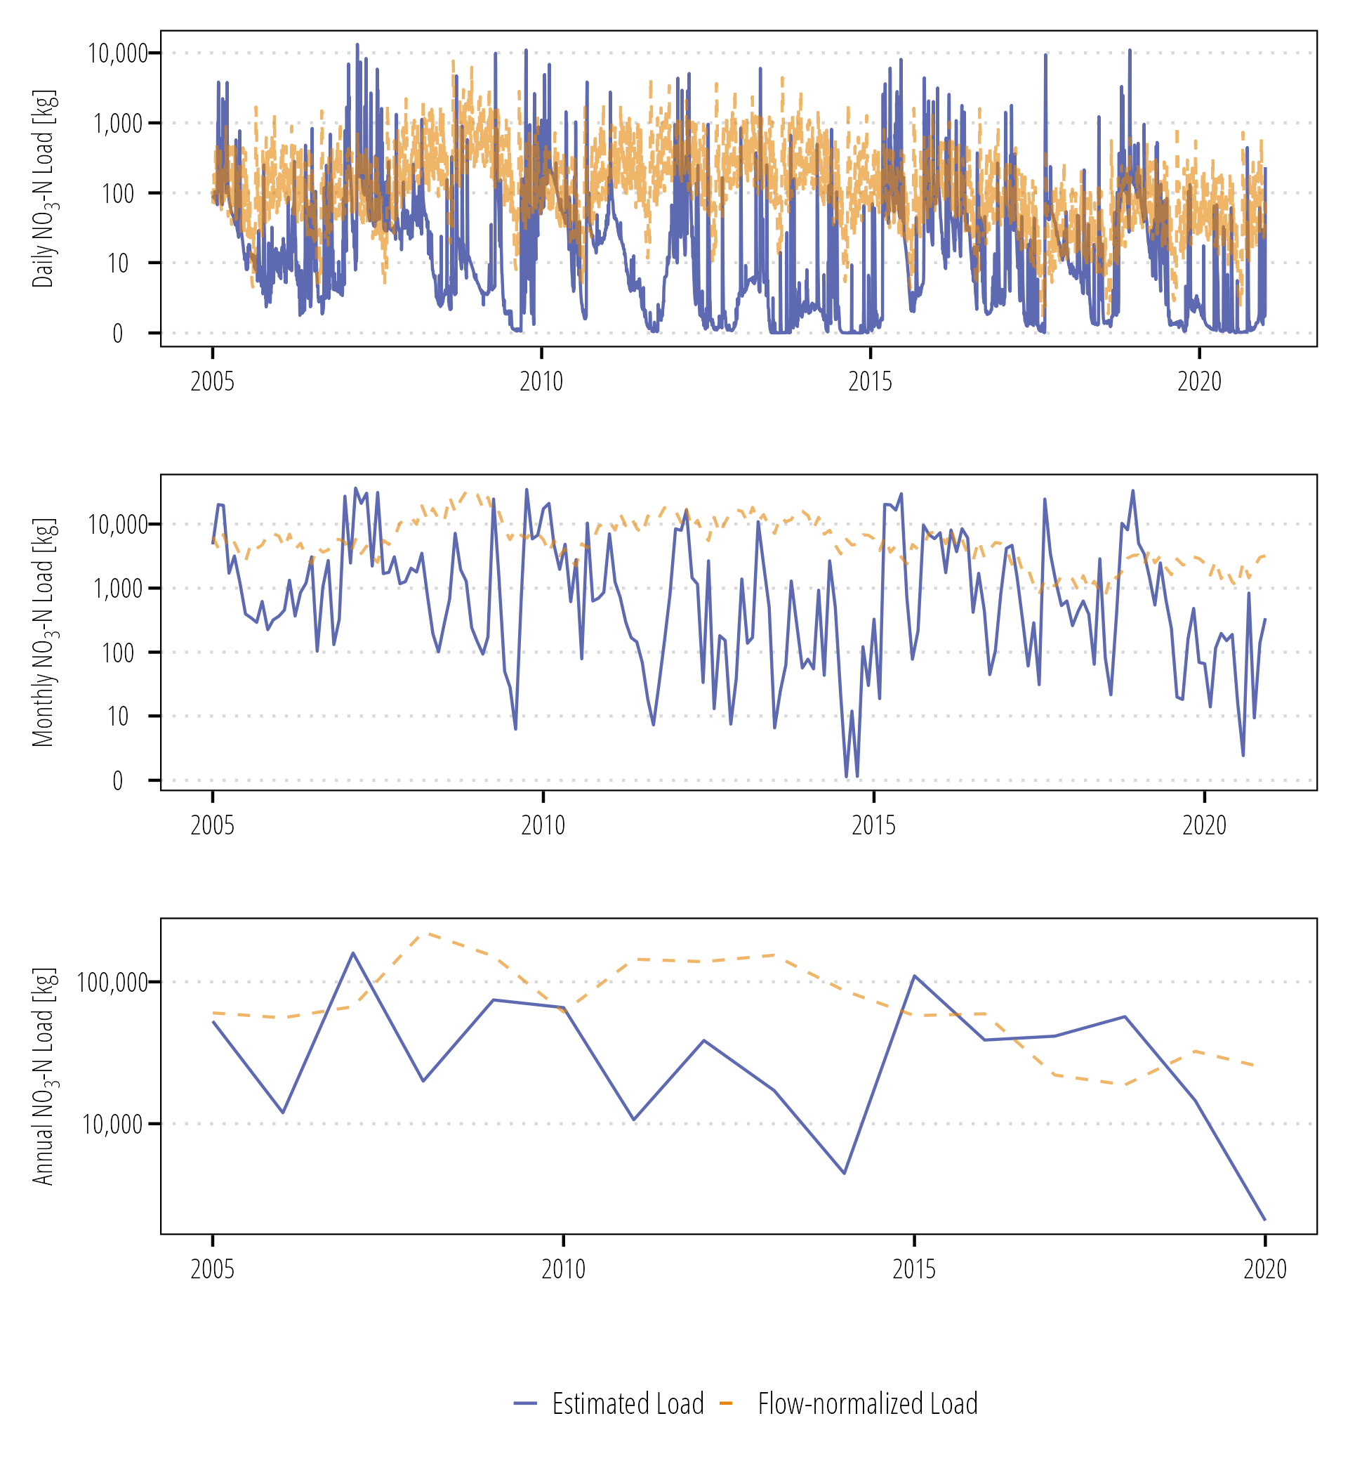

Figure . Daily, monthly, and annual NO3-N loads at Lavaca River (USGS-08164000).

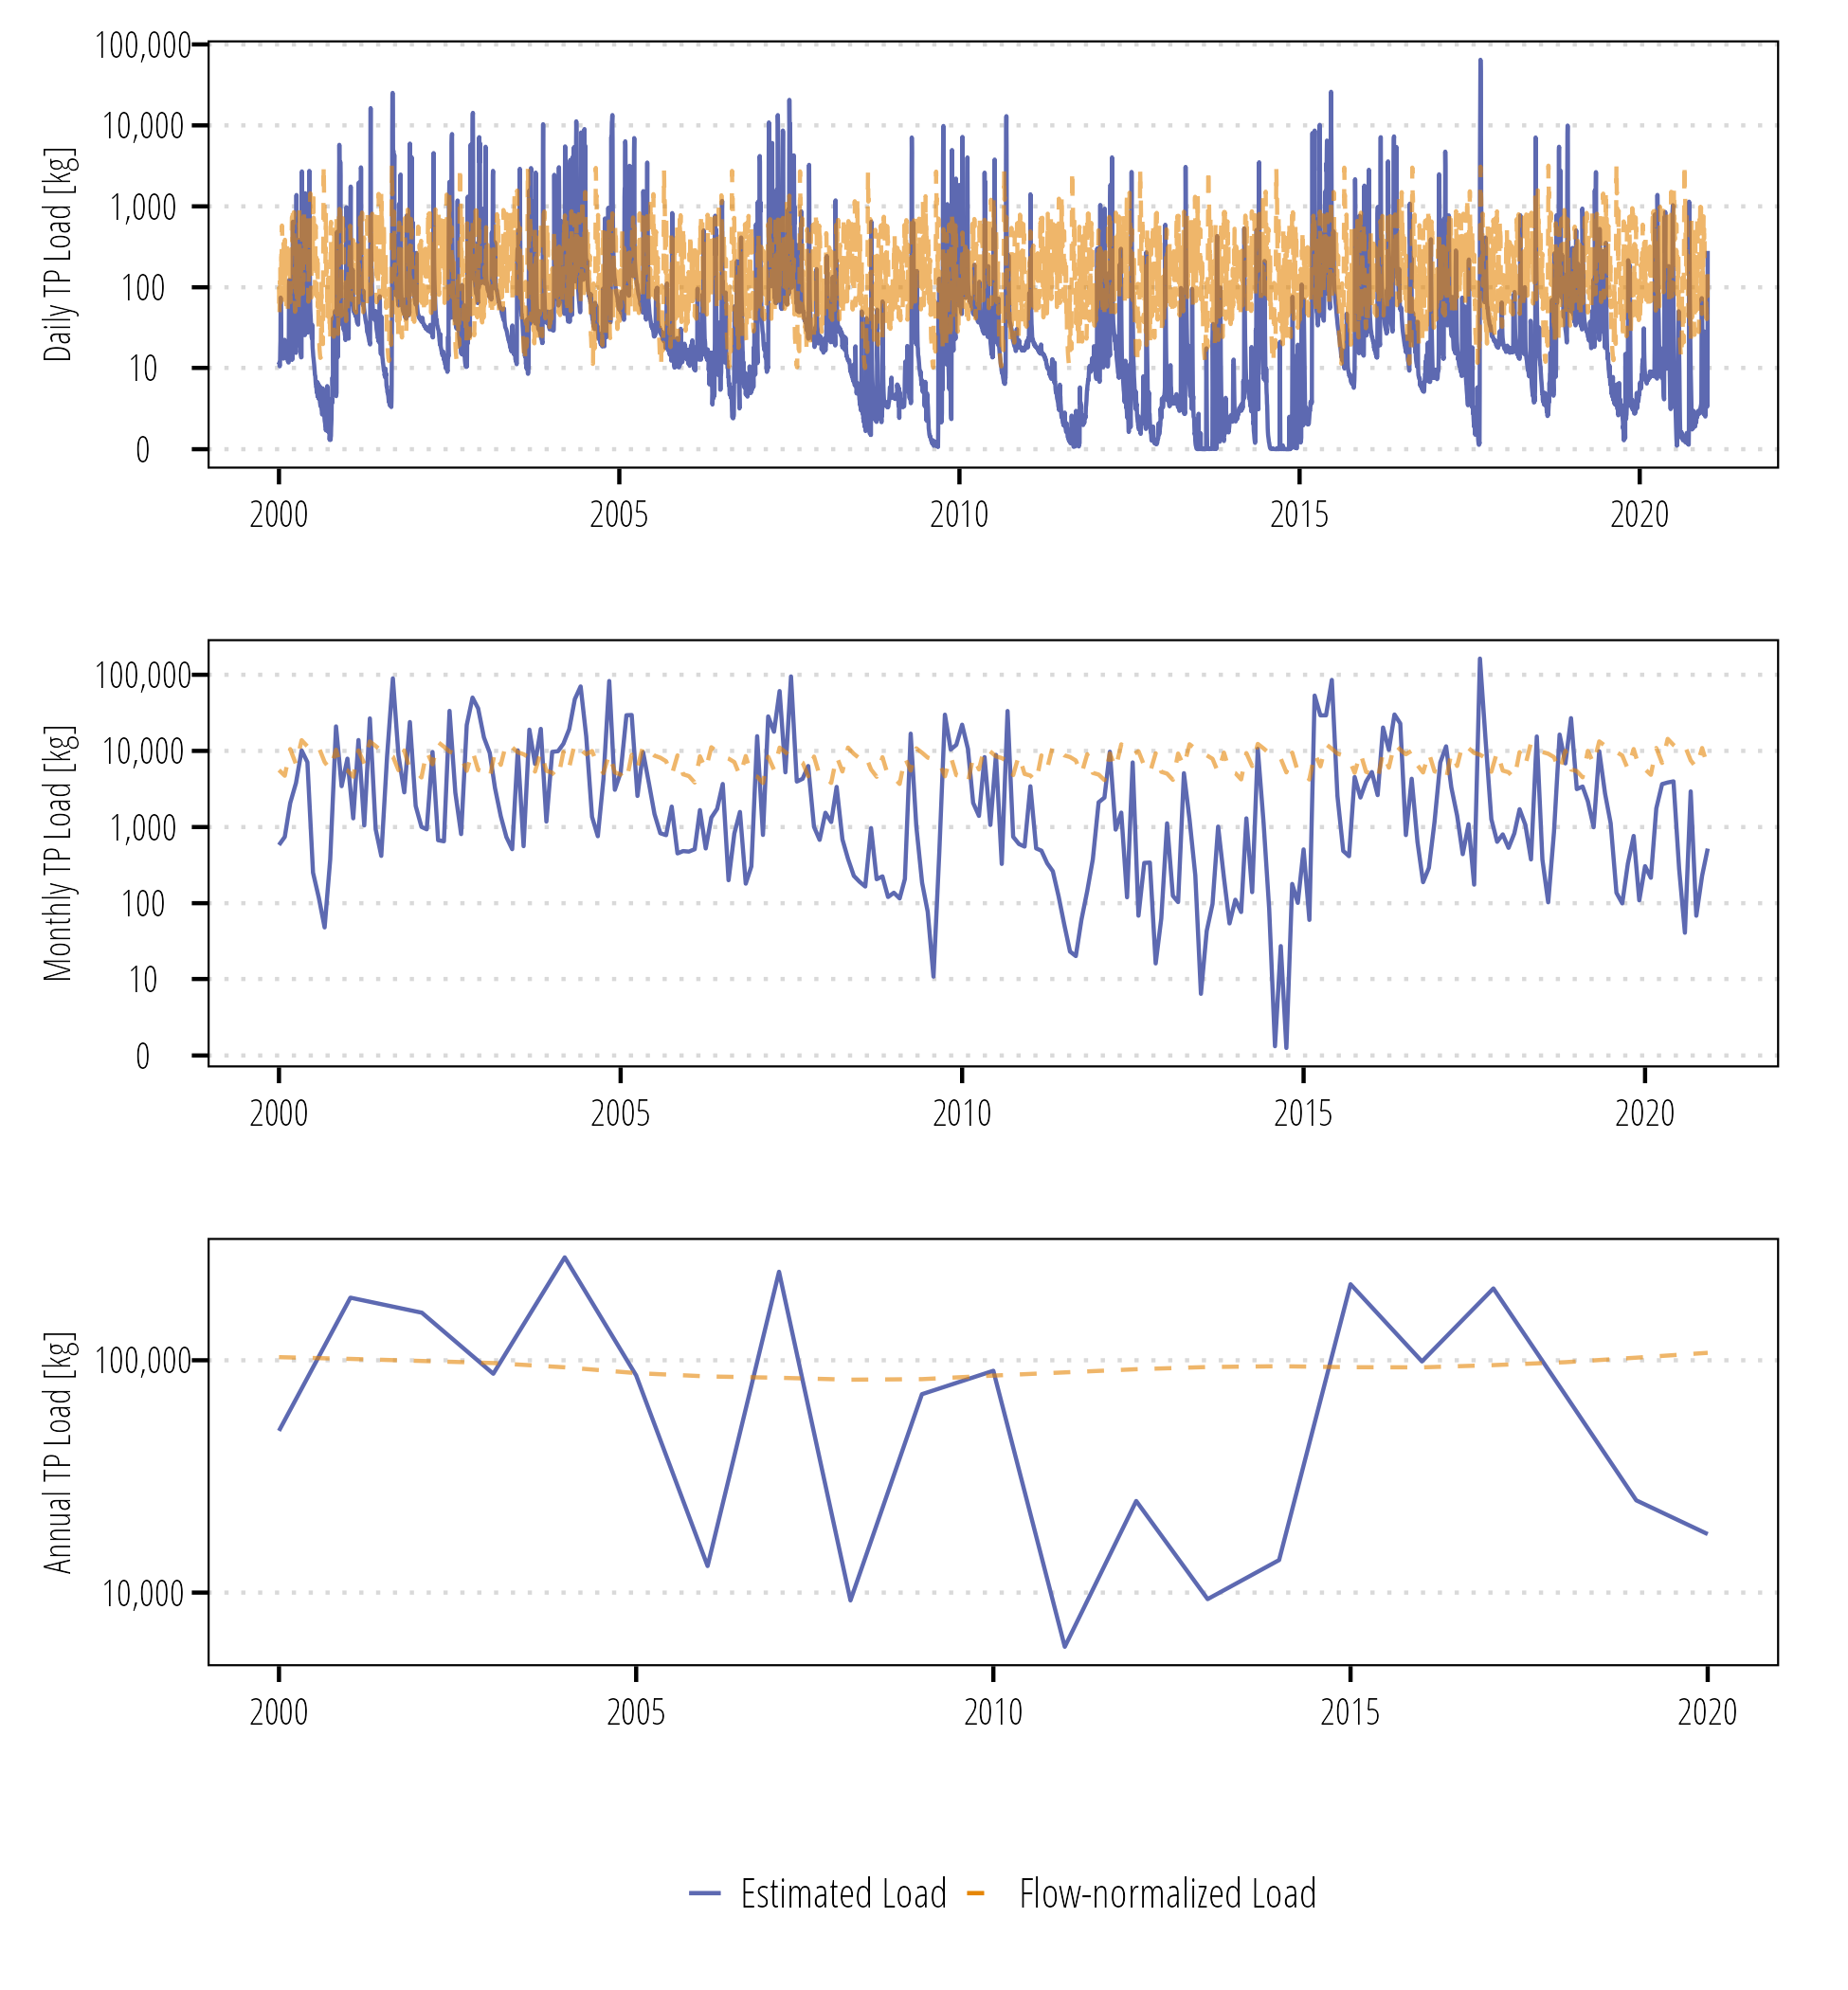

Figure . Daily, monthly, and annual TP loads at Lavaca River (USGS-08164000).

## Lake Texana near Edna, USGS-08164525

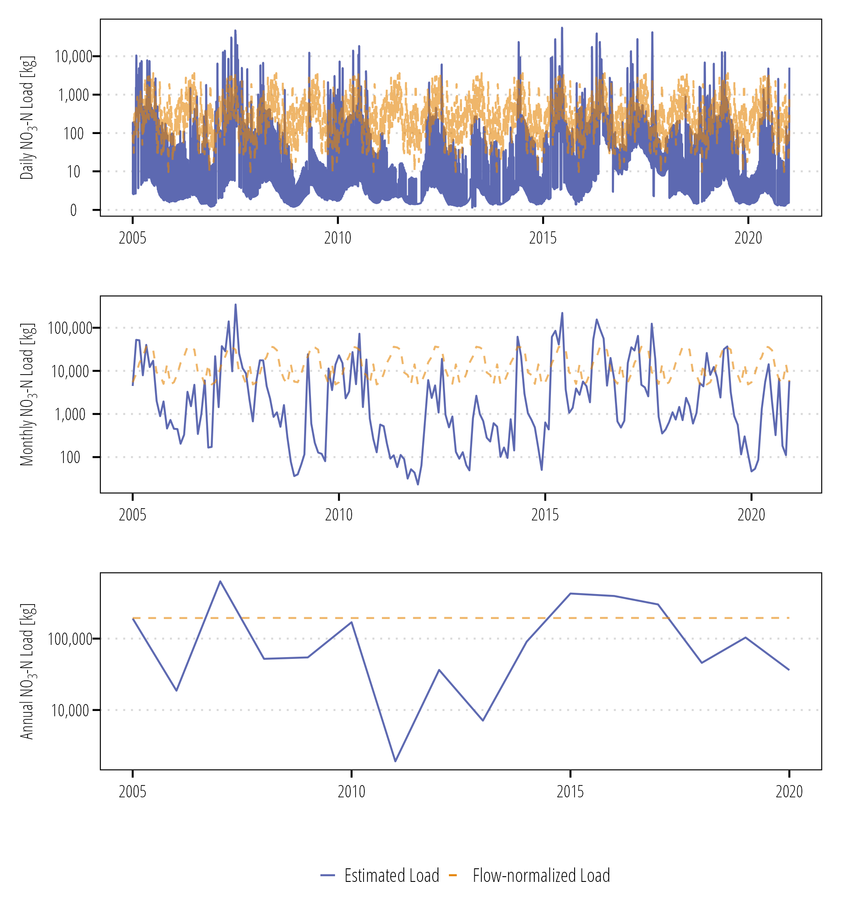

Figure . Daily, monthly, and annual NO3-N loads at Lake Texana (USGS-08164525).

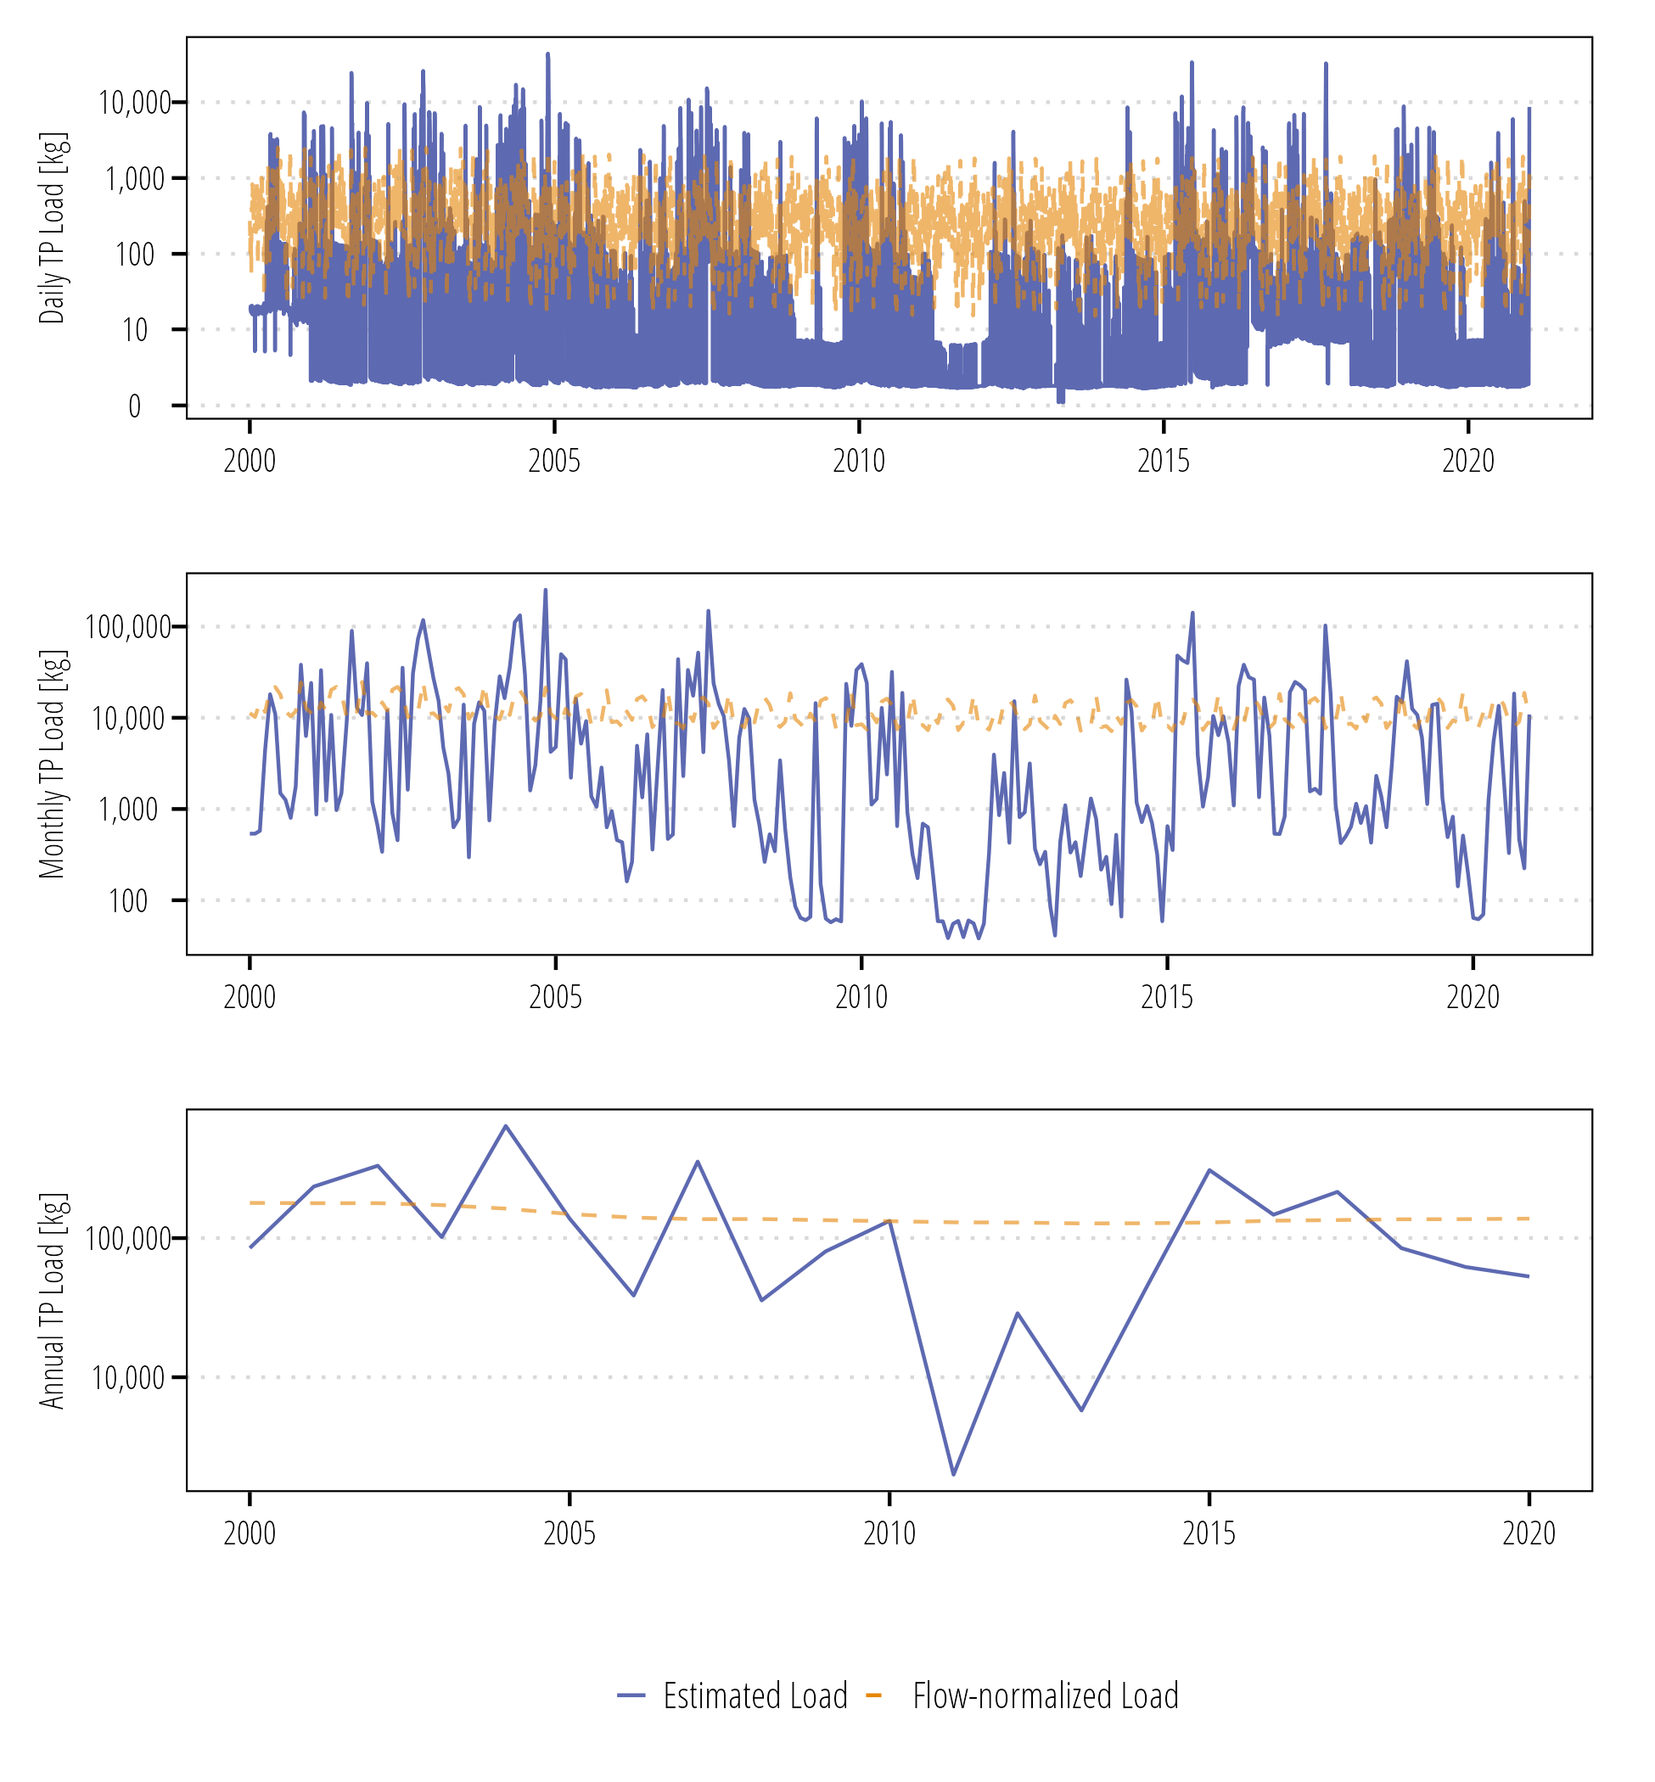

Figure . Daily, monthly, and annual TP loads at Lake Texana (USGS-08164000).

## Navidad River at Strane Pk near Edna, USGS-08164390

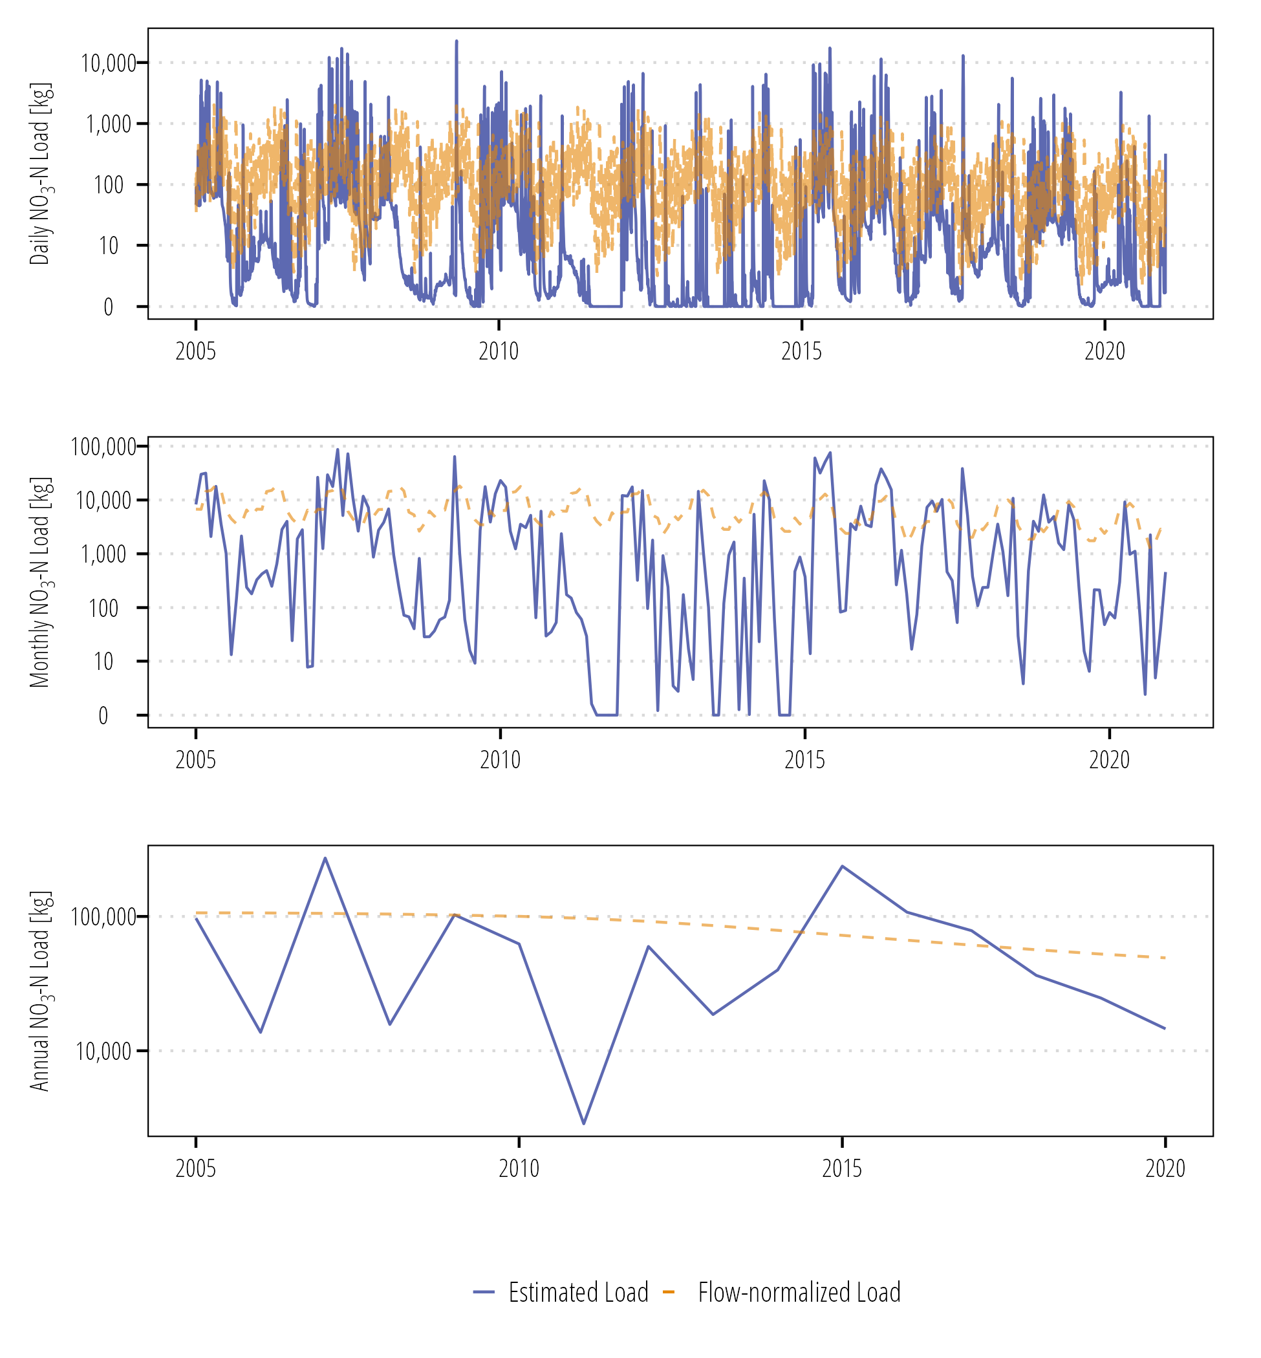

Figure . Daily, monthly, and annual NO3-N loads at Navidad River at Strane Pk (USGS-08164390).

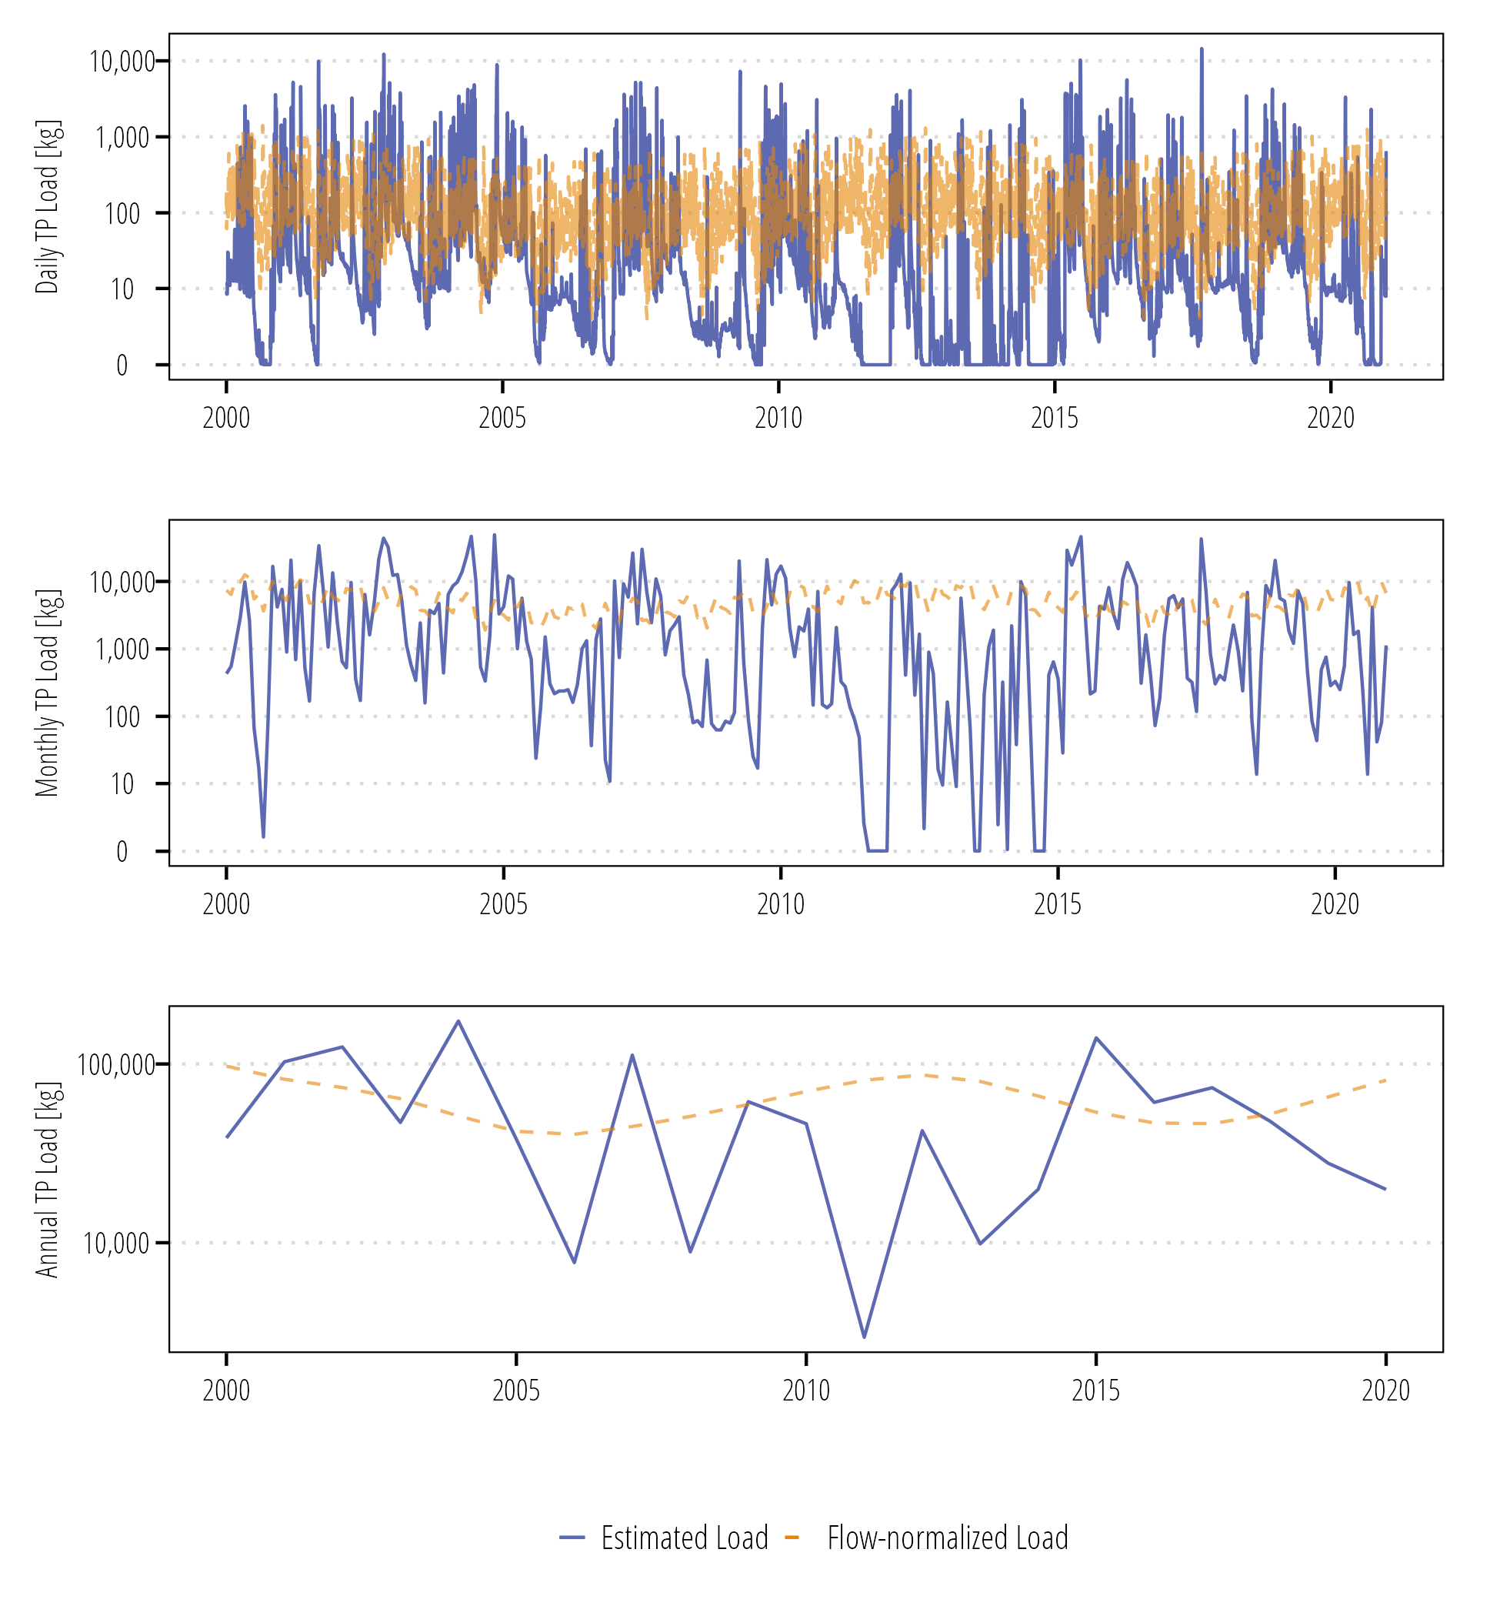

Figure . Daily, monthly, and annual TP loads at Navidad River at Strane Pk (USGS-08164390).

## Sandy Creek nr Ganado, USGS-08164450

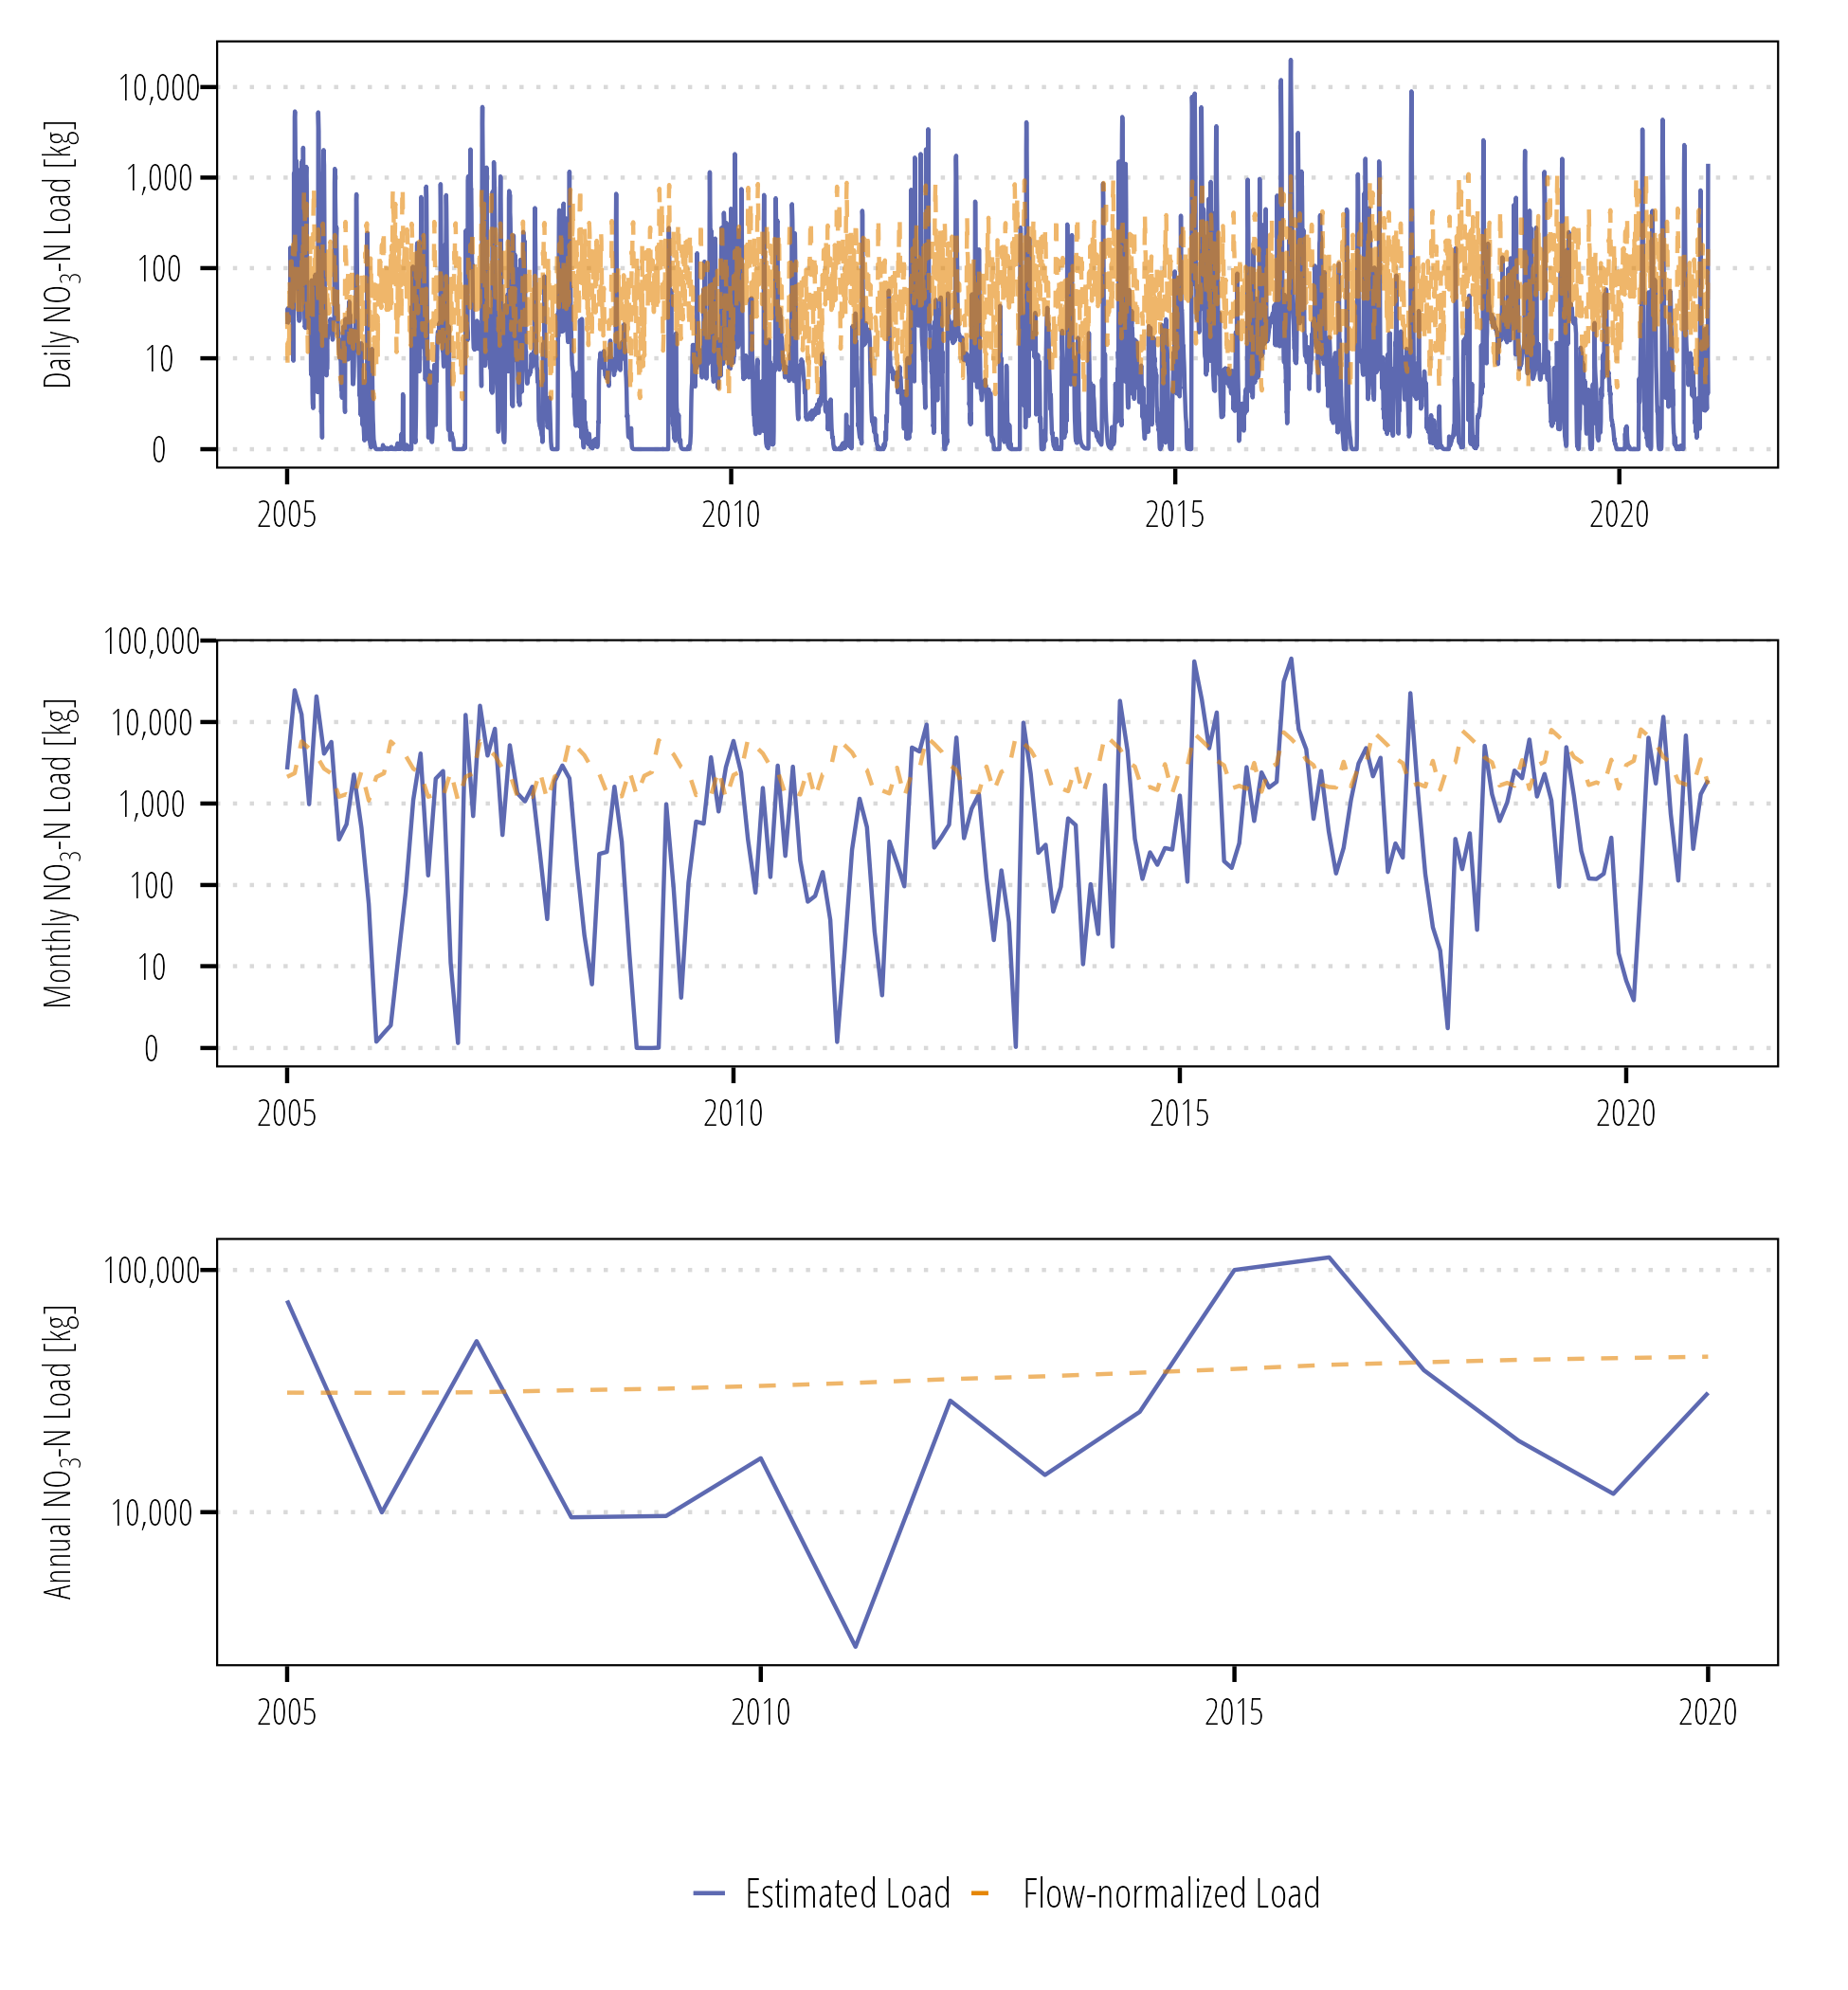

Figure . Daily, monthly, and annual NO3-N loads at Sandy Creek (USGS-08164450).

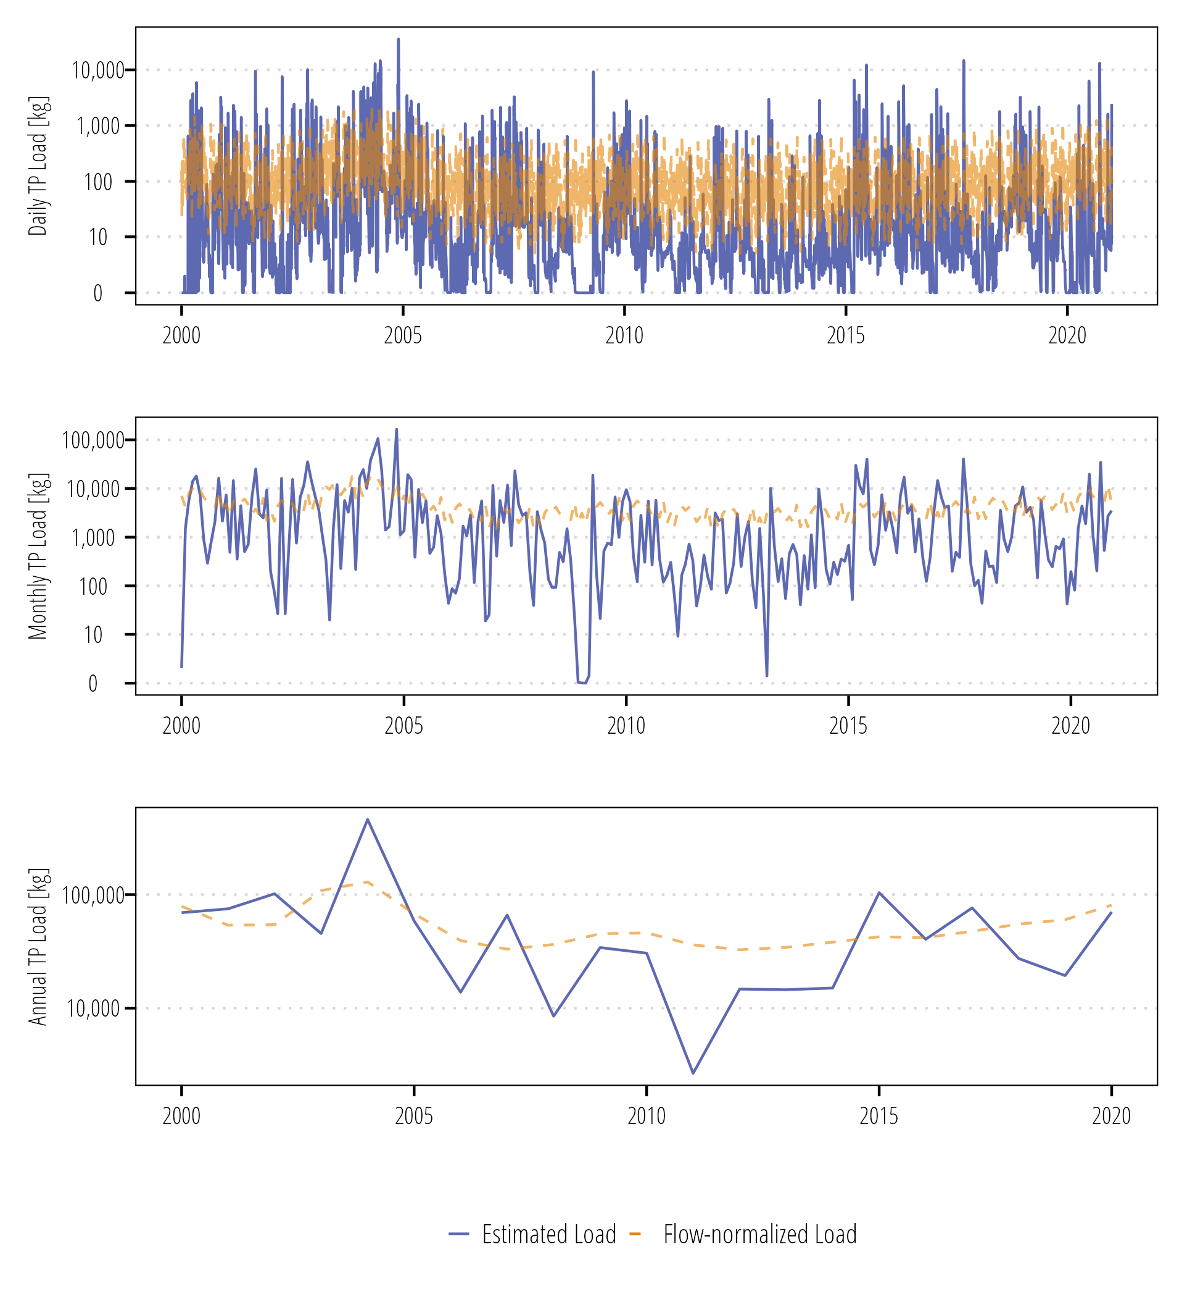

Figure . Daily, monthly, and annual TP loads at Sandy Creek (USGS-08164450).

## East Mustang Creek near Louise, USGS-08164504

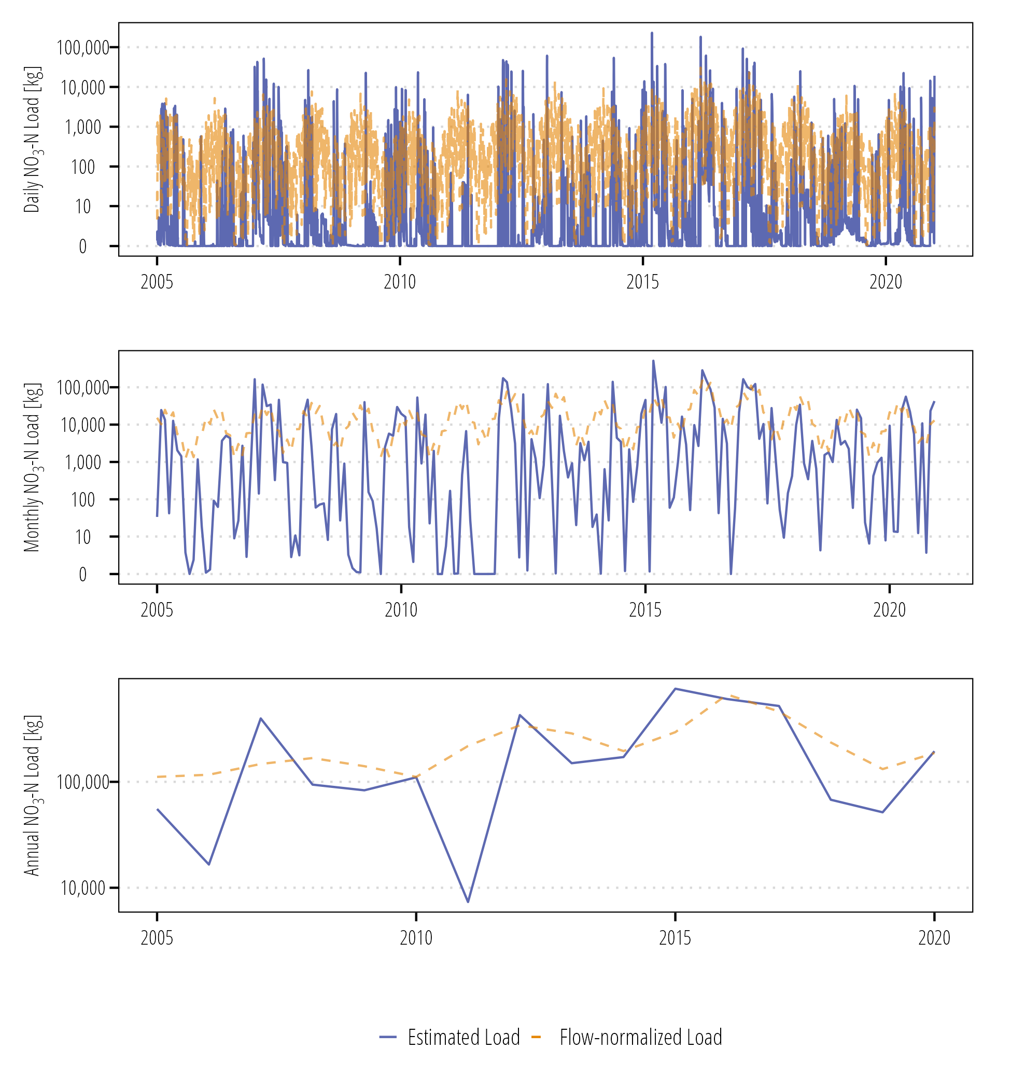

Figure . Daily, monthly, and annual NO3-N loads at East Mustang Creek (USGS-08164504).

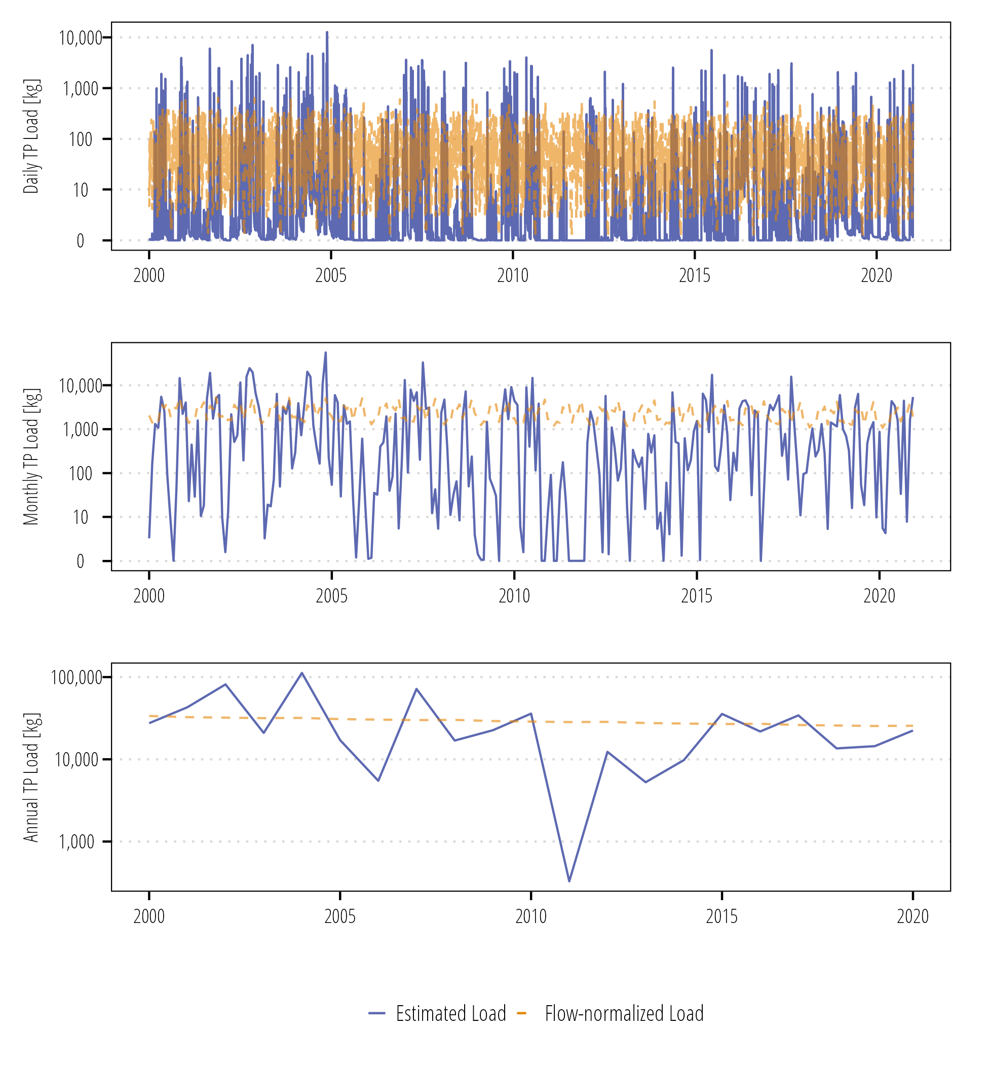

Figure . Daily, monthly, and annual TP loads at East Mustang Creek (USGS-08164504).

## West Mustang Creek near Ganado, USGS-08164503

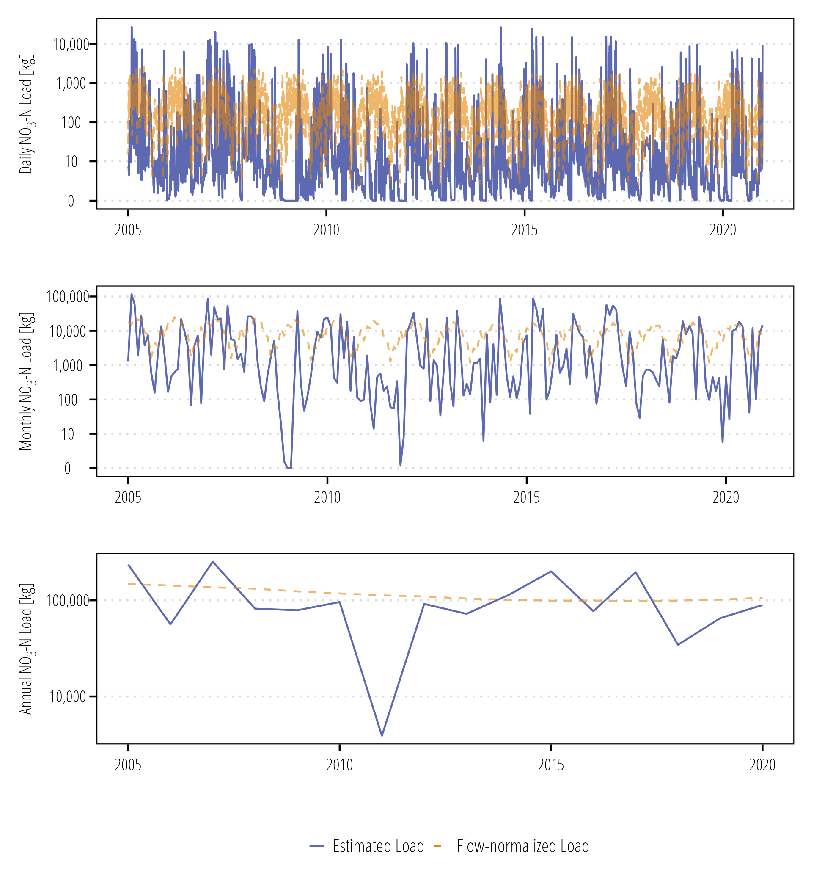

Figure . Daily, monthly, and annual NO3-N loads at West Mustang Creek (USGS-08164503).

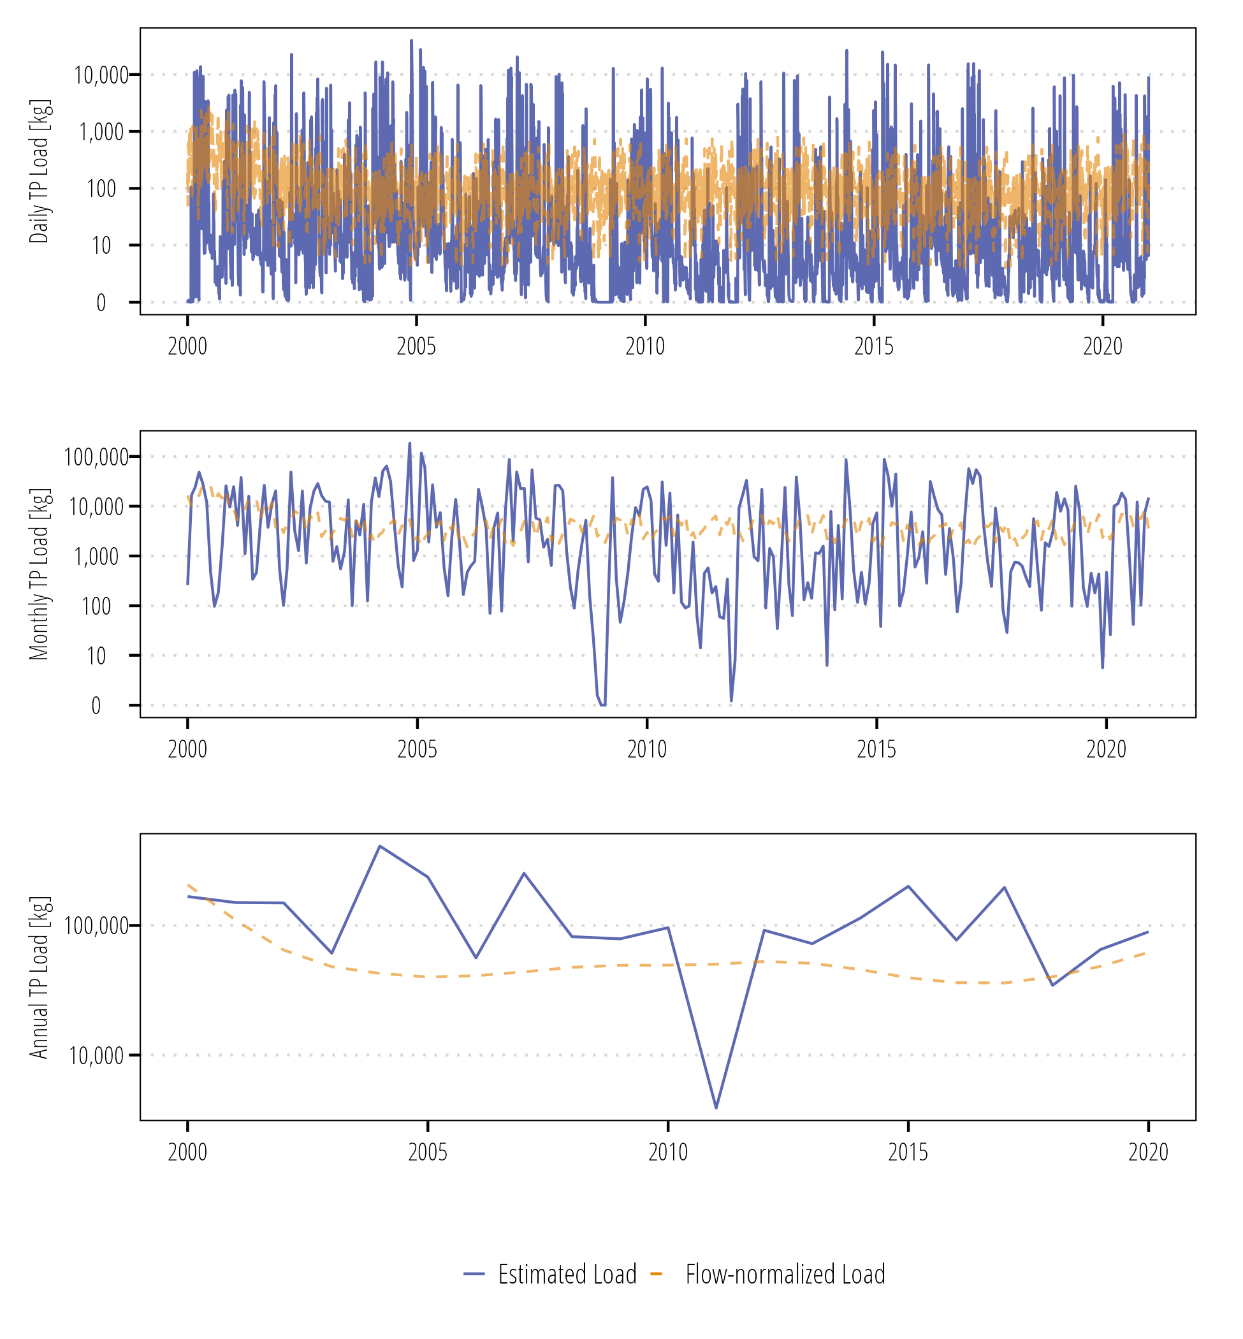

Figure . Daily, monthly, and annual TP loads at West Mustang Creek (USGS-08164503).